Finance Manual:

A Guide to Finance Policies and Procedures FY16

International Students, Inc.

PO Box C, Colorado Springs, CO 80901-2901
7222 Commerce Center Drive, Suite 200
Colorado Springs, CO 80919-2632
Phone (800) 474-4065 Fax (719) 576-5363
www.isiwebnet.net/sites/finance
Updated June 2016

This page left blank intentionally

Table of Contents
Introduction 6
Important Information About the Field Finance Manual 7
Finance Overview 9
Ministry Representatives 9
Reimbursements 10
Expense Clarification 11
Guidelines 10
Automobiles 12
Meals 12
Capital Items 12
Professional Growth 13
Other Expenses 13
Approvals 14
The Process 15
Direct Deposit Form 18
Events/Retreats/Special Projects 19
Honorariums 19
Contacts 19
Funding 19
Payments 19
City/Area/Regional Directors 20
Reimbursement Approval 20
Salary Subsidies 20
Partial Salary Release 20
Ministry Fund Account Codes 20
Fund Raising Events 20
Contracts 21
Honoria 21
Bill Payments 21
Cash Advances 22
Website and Student Activities 22
Budgets 23

Payroll 24
Overview 24
Sample Calculations 25
Taxes 26
Getting Paid 27
Back Pay/Short Pay 27
403B Plan 29
Flexible Spending Arrangement (FSA) 29
Health Savings Account (HSA) 30
Other Pre-tax Benefits 30
Budgeting Process 31
Salary 31
Expenses 32
FICA/SECA 32
Escrow 32
Staff Service Allocation (SSA) 32
Signatures and Approvals 34
Examples 36
Partnership Development 37
The 100% Plus Program 37
Partnership Development/Veteran Staff 37
Monitoring Success 37
Qualify for Partial Salary 37
Donor Receipting 39
Assignment of Codes 39
Types of Gifts 41
Methods of Giving 42
Received by Staff 43
Personal Gifts 44
Donor Envelopes 47
Receipts 48
Monthly Reports 51
Financial 51
Income Spending Status Report (ISSR) 51
Field Income Report (FIR) 54
Monthly Reports Continued 58
Donor Development 28
Month-to-Date Report 58
13-Month Report 28
Susidiary Company Practices 61
Frequently Asked Questions 62
What is in the Staff Service Allocation? 62
What if I fall short on support? 62
Do I qualify for a housing allowance? 62
Do I pay social security tax or self-employment tax? 62
What is included in a ministry budget? 62
Do I need to keep a receipt for every purchase? 62
Is there a time limit to submit expenses for reimbursement? 63
May I raise money for things other than salary and expenses? 63
What is the approval process for purchasing a capital item? 63
May I be reimbursed for child care? 63
Can I be reimbursed for meals in my home? 63
What is meant by commuting? 63
May I reimburse phone costs? 63
What are the deadlines for submitting reimbursements? 64
How often can I change my budget? 64
What is escrow and how is it determined? 64
How long do I have to submit a receipt? 64
What happens if I miss the 60 day deadline? 64
What happens if I don’t turn in my receipts? 64
Are there options for retirement with ISI? 64
Where are 403B matching funds matched from? 64
How much can I set aside for retirement? 65
How are my retirement funds invested? 65
Index 66

Introduction

Greetings! We in the Finance Department have established a system to make field financial reporting at ISI as streamlined as possible. At the same time, we are very committed to serving you faithfully and providing you with complete, accurate and timely reports that will allow you to manage your ministry in the most effective and efficient manner.

We know that you want to maximize the time you spend sharing Jesus with international students. We believe that it is our job to serve you in innovative ways that will allow you to minimize the time you spend on financial details. It is our hope that this Field Finance Manual will be the basis for streamlining your financial processes.

The IRS requires ISI to maintain an “accountable reimbursement plan.” Furthermore, they require that reimbursed expenses have two attributes: business purpose and adequate accounting. Business purpose is generally easy; it pertains to the ministry in which you are involved. Adequate accounting involves your recording such things as who, what, when, where and why. At ISI, our commitment is to conform to the IRS stipulations and yet strive to keep the process efficient!

IMPORTANT INFORMATION ABOUT THE FIELD FINANCE MANUAL

The Field Finance Manual sets forth the financial procedures and guidelines of International Students, Inc. Questions relative to the procedures contained in this manual may be directed to your supervisor or the Finance Team at ISI’s Home Office.

This manual does not constitute either an express or implied contract of employment, and nothing in this manual alters ISI’s “employment-at-will” relationship with its employees as outlined in the ISI Employee Handbook.

Licensed, ordained or commissioned ministers are solely responsible for paying the Self Employment Contributions Act (SECA) taxes and for filing the Schedule SE (Self-employment) forms when federal income taxes are prepared each year.

The Finance Team at ISI is not authorized to give tax advice. Employees are strongly urged to secure a tax advisor locally who can assist in planning regarding tax matters.

ISI expects its team members to operate within the guidelines of these established procedures. A team member’s decision not to do so may result in disciplinary action up to and including discharge.

The guidelines outlined in this Finance Manual are subject to change at management’s discretion. Team members must take responsibility to be aware of the periodic updating of this manual when announced by the Finance Department and for reviewing all revised and new procedures distributed.

This page left blank intentionally
- Finance Overview

Each staff missionary is responsible for raising 100% of their personal budget package. ISI does not guarantee salaries or funding except for: all liability and worker’s compensation insurance, payment of wages to non-exempt employees, and other selected event and ministry expenses paid with monies raised by the Home Office. Payment of missionaries’ salaries, ministry expenses, and benefits are subject to funds available in their personal ministry accounts at specified points during the financial calendar.

Administration of benefits and ministry expenses are paid first before salary. When income is below budget, salary is affected. When funds received exceed the approved budget, they are held in reserve for a future month when income is below budget, subject to limitations imposed by executive management.

ISI has an accountable reimbursement plan as set forth according to policies established by the IRS. We are continually looking at these guidelines and making changes to our procedures in order to comply with the IRS. All expenses must be submitted to the Finance Department within 60 days of being incurred, receipts greater than or equal to $75 must be sent in with the reimbursement request, prior to the request being processed, and advances must be cleared within 120 days. (For example, if you purchase a plane ticket on Jan 15 for a trip on June 20, the 60 days is based on Jan 15th not on June 20th.) We only pay reimbursements if the funds are available in your account. In the event that the funds are not available, we will hold the reimbursement to allow you time to raise the necessary funds; but the hold will only be for approximately six months.

Ministry Representatives

Ministry Representatives are allowed to submit expenses for reimbursement. However, there are some limitations. We do not allow reimbursement of capital equipment (i.e. computers, furniture, etc.). Most of our Ministry Representatives do not have close contact/supervision from ISI since they are not employees. As a result, we do not have the degree of control necessary to ensure safeguards of capital equipment or how it is used for ministry purposes. In addition, capital equipment must be returned to ISI or purchased back from ISI once an employee resigns from the company. Since Ministry Representatives are not employees, this policy would be difficult to enforce.

City/Area/Regional Directors

Please reference section II for additional information.

- Reimbursements

ISI categorizes reimbursements in two ways: ministry and special.
- Ministry reimbursements are expenses which are drawn on your own ministry account which was assigned when you were hired. This account is also where you are being paid from. These reimbursements are processed once a month and are usually paid within the first 5-10 business days of the month.
- Special reimbursements are expenses which are drawn on a city, regional, or other special account. These accounts are set up to allow staff to raise money for a specific purpose, like an overseas trip or a computer. These reimbursements are paid twice a month on the second and fourth Thursday based on when they are received in the Home Office provided there are funds available and the appropriate authorization has been obtained.

ISI will reimburse ministry expenses in each of the following seven categories:
- Transportation: mileage, tolls, parking permits, parking expenses, etc.
- Donor Care: prayer letters, newsletters, meals with donors and potential donors, entertaining donors/potential donors, presentations for donors, gifts to donors/hosts (limited to $25 per gift per person), etc.
- Office Expense: office rent, telephone expenses, pens, pencils, staples, post-it notes, faxes, printer paper, printer cartridges/ribbons, postage, Fed-Ex/UPS, etc.
- Out-of-town Travel: airline tickets, rental car (plus gas), hotels, food while traveling (NOT donor meals!), out-of-town cab/bus/subway, etc.
- Professional Growth: seminars, books, tapes, ISI conferences, training, etc.
- Ministry Operations: meals with international students, materials for ICF meetings (including snacks), gifts to students/volunteers/hosts (limited to $25 per gift per person), volunteer appreciation, planning meetings, local meetings/conferences that you set up, entertaining, etc. This does not include personal meals.
- Capital Equipment: computers, calculators, file cabinets, telephone, office furniture, and other equipment with a useful life greater than one year.

Additional guidelines

All reimbursement requests must be $50 or greater in order to be considered for processing

Staff are allowed one regular reimbursement per month and two city/special reimbursements per account per month.
- Receipts must be submitted for all expenses $75 or greater. However, we may request additional receipts as needed for clarification until the request has been paid.
- Expenses must be submitted within 60 days of being incurred.

Checks are processed on Thursday. Any payment that is needed for that week must be received in the Finance Department by noon (12:00pm MST) on Wednesday prior to the check date. If we do not have it, the payment will be made in the next scheduled check run.

Expense Clarification

Receipts
ISI adheres to IRS regulations which state that a receipt is not required for an expense which is less than $75. This applies as long as we have the relevant information on the reimbursement form: who, what, when, where, why, and how much. For your convenience, the ISI reimbursement form has these headings on each page to prompt you for the information. However, ISI reserves the right to request any receipt (or proof of purchase), regardless of the amount, in order to ensure adherence to other policies as well as accuracy. This also falls into the audit realm of periodic spot checking until the request has been paid.

We do require a receipt for expenses that are greater than or equal to $75. ISI now requires receipts to be sent in by snip, scan (email), fax, electronic picture or hard copy in the mail. If you are required to send a receipt as back up for an expense, the receipt MUST accompany the reimbursement request. If you do not submit the receipts with the request, your request will not be processed until the receipt has been received. In addition, after 30 days any expense which requires a receipt, but for which we have not received a receipt, will automatically be disallowed. The reimbursement total will be modified and paid out in full. Should you locate the expense receipt later, you may always resubmit the expense with a request for an exception to the policy. The purchase of a scanner may be allowed as a reimbursable expense.

Telephone
Basic land-line phone expenses are not reimbursable. Only a separate business telephone line specifically installed for ISI business use is reimbursable. Long distance ISI related calls may be claimed. Simply highlight those long distance calls that had an ISI ministry purpose on the original phone bill. Then write the total of those long distance calls on the first page of the phone bill (in the upper right hand corner) and include that amount in your total on the office expense page.

ISI business telephones should not be used to make personal long distance calls, unless a personal phone card is used so the call does not appear on the office phone bill. Additional line charges for computer phone modems, smart tablets, as well as email or Internet service charges are reimbursable.

Cell-phone charges are reimbursable if used for ministry. We reimburse cell phones based on the % of business use. This percentage should be calculated each month by dividing business minutes used by the total minutes used. Record-keeping and reimbursement would be easier if you maintained a cell that was 100% for business or 100% for personal use as this would eliminate the need to calculate the actual % of business use each month. If the amount is less than $75.00 you do not need to send the receipt. However, we ask that you include the % of business use on the expense form. At least 85% of the cell phone usage must be for Ministry use to be reimbursed at 100%.

Auto/Mileage Expense
ISI ministry related mileage will be reimbursed at the standard IRS mileage rate, based on mileage recorded on the Mileage Log. Mileage to and from your principal place of work is not reimbursable. It is considered commuting by the IRS. Trips that are essentially personal (e.g., if you go out for dinner, stop at the dry cleaners and at a stamp machine for ISI postage) are not reimbursable. Mileage to attend church is not reimbursable, unless an international student was picked up. Then that portion of your trip that was out of your way to pick up students is reimbursable. If a vehicle is borrowed (from a church, student or volunteer), mileage cannot be claimed; however, actual fuel receipts may be submitted. It must be stated very clearly that this is not your vehicle and to whom the vehicle belongs. To complete the Mileage Log, you will need to fill in the date, miles driven, and ministry purpose of the trip. The mileage rates are update twice a year (Jan & June); therefore it is required that staff update their forms at that time as well.
Auto Misc Expense

Meals
Meals in your home may be reimbursed based on the Monthly Meals Sheet. The Monthly Meals Sheet was created so that you may receive reimbursement for food consumed by students and donors which was originally purchased for your consumption. Keep in mind this would not include your meal and/or your spouse/children.

For example: you and your family are just sitting down to dinner when a student drops by to visit. It would not be very polite or hospitable to ask them to come back later or wait in the living room while you finish dinner. Instead, invite them in and use the time to get acquainted.

This policy alleviates the cumbersome process of keeping grocery store receipts and highlighting the appropriate items for reimbursement. When you provide meals for international students or donors in your home, you are entitled to $4 per guest for breakfast, $7 per guest for lunch, and $10 per guest for supper. There is a limit for reimbursement of up to seven guest allowed for any given meal in your home. Allowing more guests than that gives the impression we are allowing staff a means to avoid the IRS rule for receipts to be reimbursed over $75.

Restaurant meals must list the full names (confidentially) of each person, their title, and the ministry purpose of the meal. Receipts over $75.00 must be sent to the Home Office with the request.

Capital Expense
This includes items such as desks, filing cabinets, printers, copiers, etc. For any capital item which involves computer equipment, you must contact either the Home Office or your RFD to make sure it meets our standards (there is a separate policy regarding the purchase of computers). Any capital item which is equal to or greater than $2,500.00 must have two approvals: your RFD and the Home Office (to verify funds available). Any capital purchase under $2,500.00, and not involving computers, simply needs to be primarily a ministry related expense. We may also require from time to time that another staff member verify that your home office meets the IRS requirement before we reimburse certain capital expenses.

Any major capital item equal to or greater than $2,500.00 is an asset to ISI and becomes the property of ISI. We will depreciate its value over the life of the asset. Their use and location are determined by the Home Office. In the event that a staff member who has purchased major capital items resigns, ISI will determine the value of the asset (based on the depreciation schedule) and negotiate the assets continued use for ministry. This does not apply for Ministry Reps.

Professional Growth

Includes but is not limited to seminars, books, tapes, ISI conferences, training, etc. There are a few things to discuss regarding approvals. Educational expenses such as taking a college course (whether towards a degree or not) require approval from the Home Office is covered in additional details in the Employee Handbook.

Seminars and conferences also need to have some additional approval. Parameters such as duration, location and cost play into whether or not this would be a reimbursable expense.
Your immediate supervisor or RFD should be informed and asked if you can attend. This is to ensure that attending the event does not negatively affect your local ministry requirements; as well as to verify that attending the event will enhance your ministry with ISI.

Other Expenses

Childcare expenses are reimbursable for ISI events only if the childcare is provided for the benefit of international students who have children. Childcare should be provided if staff feel it will encourage more participation. Support for this expense should be a receipt signed by the childcare provider. This does not include childcare for your own children.
- Household items are non-reimbursable. Camera and video equipment is reimbursable if purchased primarily for ministry use.
- According to the IRS section 162, we cannot reimburse for expenses incurred by dependents (children) even if it directly relates to the ministry of ISI. However, we can on occasion pay you the amount in the form of taxable income reported on your W2.
- Insurance: ISI does not have a Health Reimbursement Account (HRA) plan under IRS section 106 for reimbursing insurance premiums paid with after-tax dollars. However, we do have an FSA & HSA plan which will be discussed later in this manual.

Approvals

Each staff member is the approver for expenses on their ministry, special, and/or escrow account providing they have met any other guidelines which are required (i.e. computer purchases, overseas travel). A reimbursement expensed on a city, regional or National Ministry Fund (NMF) account must be approved by the owner of the account prior to submitting to the Finance Department for processing. If the owner of a city, regional or NMF account submits the reimbursement, it must be approved by their supervisor. This approval process is done by filling out the reimbursement and sending it to the account owner or supervisor for their approval. That person will forward it to the Finance Dept. with their approval. For your convenience and assistance, if you use one of these account codes in the Dept./Project space, the form will notify you who the account owner is.

A staff member may authorize another staff member to use their ministry account for a specific reason. In that case, the original staff member must sign off on the reimbursement as a supervisor because they are the owner of the account being charged. We always keep in mind what the donor’s intent was for the gift.

REIMBURSEMENT PROCEDURES

- Gather all receipts, notes and scraps of paper with reimbursement expense information on them. If you are submitting a reimbursement for two or more separate projects, please submit a separate reimbursement for each of the projects. DO NOT COMBINE in one report. This includes all escrow expenses.

- Sort into expense groups according to the summary sheet.

- Open the reimbursement spreadsheet in excel. Notice that the due date is automatically stated at the top of the page. Start by typing in your name, the account/department/project/fund code, the description, and submit date into the required yellow boxes .
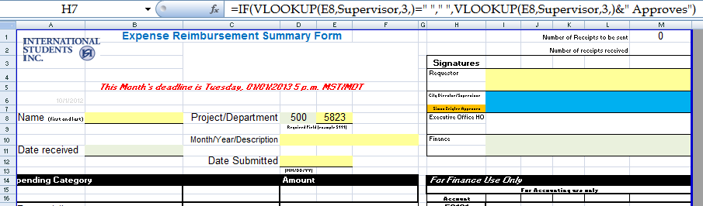

- Click on the tab (located at the bottom of the spreadsheet) which corresponds with the expense category you are claiming for reimbursement.
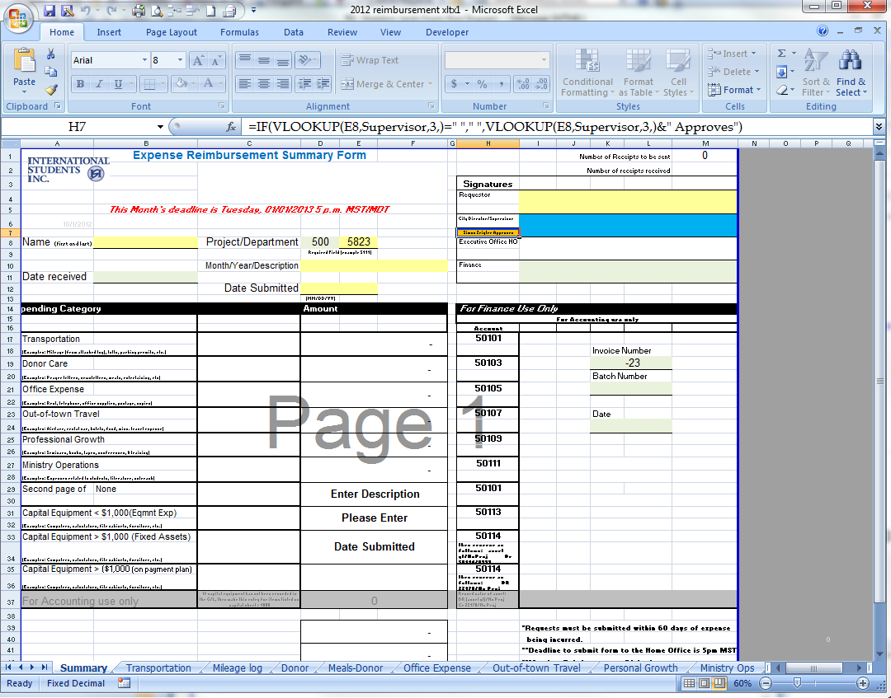

- List ALL information asked for related to every expense for this category. The information provides us with the necessary proof for the IRS in case of an audit. If you need more space for a particular expense than one line provides, use the next line as well.

- Note: at the bottom of the page there is a box labeled “Total of Receipts to be Mailed”. If there is an amount in this box when you have completed filling in all of the expenses for this category, you need to send that many receipts to the Home Office, as these amounts are equal to or greater than $75.00 each. They should appear with an * by them.

- If you are required to send in receipts, you may send the receipts by snip, scan, fax, email, or snail mail (least preferred) to the Finance Department. If you have receipts for two different account/reimbursement requests please keep them separate by using staples and attach a note to explain which request they belong to. If you are emailing your receipts, it should be included along with the reimbursement request vs. in a separate email so they may be matched up correctly and not lost.

- All required receipts must be submitted with the request to the Home Office within 30 days of the reimbursement being submitted. If the receipts are not received within 30 days, the items will be automatically disallowed and the reimbursements will be processed for payment. We will not pay the reimbursement if we do not have the receipt for expenses $75 or greater.

- Look at the total amount on this expense category and then check to make sure the same total appears on the Summary Sheet for this category. If it does not, call the Home Office 800-576-2700.

- Repeat steps 5-9 until all expenses are listed.

- Save the file on your computer before transmitting to the Home Office. A suggested file name would be: (month and year) (city, regional, ministry, etc) (acct number).xls. You do not need to print a copy for yourself unless that is your preference.

- Email the reimbursement form: once you have completely filled out the form it should be emailed to the Finance Department (or supervisor if it requires their approval). You should only send one reimbursement per email and it should include ALL additional back up documentation needed for processing.

- If you need to have an approval from a city or regional director, a supervisor, or a Home Office representative, email the form directly to them. You do not need to cc the Finance Dept. The approving director/supervisor will FORWARD the form to Finance (reimbursements@isiwebnet.net) via email. Since we are requiring an electronic form, the form must come from the supervisor to Finance so we know that the supervisor has actually approved the reimbursement. We will not accept a reimbursement that has not been approved/forwarded from the appropriate director/supervisor.

- Deadline: Your monthly request, which shall generate reimbursement from your ministry account(s), must be received by the Finance Department on or before 5 p.m. MST on the first of the month to be reimbursed that month. When the first of the month falls on a Saturday or Sunday, the form must be received by 5 p.m. MST on the last working day of the prior month. Reimbursements are paid by direct deposit and are sent between the 5th and 10th business day of the month.

City, special and NMF reimbursements are due to the Finance Department with ALL appropriate approvals by noon on Wednesday the 2nd or 4th week the month.

Reimbursement claims impact payroll, thus the early deadline date. If your Ministry Report and/or statistics are late, your reimbursement will not be paid that month even if the reimbursement arrived on time. (Please reference your Memorandum of Agreement regarding the obligation of timely reporting.)

- In the event that an adjustment is made to the reimbursement amount, we will send an explanation of the adjustment by email.

- A disallowed expense may be appealed. If you feel the claim is valid, email the form along with any additional documents requested or needed to plead your case to the Senior Accountant at finance@isionline.org. Do not send your appeal to reimbursements@isionline.org.

- If the account indicated on the summary page is NSF, you will be notified by email that the reimbursement is not being paid. We will hold the reimbursement until there is sufficient funds (no longer than six months) and then pay it on the next normally scheduled day.

- ISI prefers to pay reimbursements by ACH (automatic deposit). [A copy of the “Authorization Agreement for Automatic Deposits of Reimbursement” is at the end of the reimbursement section in this manual for your convenience.]

In the event that you do not want to file your request by email, you may submit it by fax or snail mail. However, you are still subject to the same deadlines. Follow the steps above, print each page with information on it and fax to 719-576-5363 or mail it to:

ISI
Attn: Reimbursements
PO Box C
Colorado Springs, CO 80901-2901

Authorization Agreement

To Direct Deposit in US

Company Name: International Students Inc

I hereby authorize INTERNATIONAL STUDENTS, INC., hereinafter called ISI, to deposit my (our) payroll checks to my (our) account(s) to the DEPOSITORY named below. Only one checking and savings account permitted per person. I also authorize ISI to debit my account in the event it is credited erroneously. I have attached a voided check to be used to set up the direct deposit.

Check all that apply:       Payroll  Reimbursements

 New  Update

Indicate how to dispurse:

 Savings Account Amount $ Net Deposit

 Checking Account Amount $ Net Deposit

 Wire Transfer Amount $ Net Deposit

Bank Name

Address

City, State, Zip

Routing Number :

Swift Code:

Account number:

This authority is to remain in full force until ISI has received written notice from me of a change of DEPOSITORY, ACCOUNT, or AMOUNT OF DEPOSIT.

Print Name

Signature Date

For checking account deposits (new or changes), you MUST attach a voided check.

For savings account deposits (new or changes), you MUST attach a deposit slip.

Please note the first check you receive will be a “live” check, not a notification of deposit.

III. Events/Retreats/Special Project

When planning an event, retreat, or special project it is always best to check with the Home Office prior to advertising or purchasing items for the project to ensure that it is an ISI approved project. There are many things which need to be looked at and considered prior to this such as: liability insurance, fund raising, legal obligation of ISI, etc.

Honorariums: You may of course want to provide honoraria for special speakers, guest, or other honored attendees. All honoraria must be given by check and issued through the Home Office to comply with IRS regulations. You will need to provide an email request and complete a requisition form or email an invoice to finance@isionline.org. List the name, address, amount, reason, and project paid from. This should be sent at least 1 ½ to two weeks prior to the date needed to allow for processing and mailing. Please remember that Finance processes check requests received in the office by noon on Wednesday for that week.

Per the IRS rules, we must have a W9 filled out for each recipient in order to capture the proper name, address, and social security number. The IRS requires that we send a 1099 for honoraria if the amount exceeds $600; therefore we caution on the safe side and require this information for ALL honoraria in order to ensure we have the information prior to sending a check. We understand that you may not be requesting $600 but over the course of a year it may be that another check is sent which combined puts them over $600.

Contracts/Deposits: must be submitted to the Executive Office for review and signature. ISI staff are not legally able to commit/bind ISI in a contractual agreement.

Funding: Do you need to set up an event code for your website to enable students or attendees to register and pay online?

Payments: this would be if you designed an item such as t-shirts, ISI logo items, etc. which you want to sell to students, volunteers, or other staff members, please contact Website and Publications Coordinator (rmiller@isionline.org).

Events fees and registrations: go to the ISI Team Website (http://www.isiteam.org/) and fill out the required form.

Contributions/Donations: Please contact Website and Publications Coordinator (rmiller@isionline.org).

Payments: to make a payment for items related to an event, retreat or special project, you may make the payment yourself and submit for reimbursement. These accounts are reimbursed on a bi-weekly basis. If the payment amount is large and would create a financial hardship, you may make a request to the Finance Department on a requisition form (if time allows) and we can issue a check to the vendor directly from ISI pending the funds being available in your account. Please download the form from the Finance website (http://financeisi.weebly.com/other-isi-forms.html) and email with appropriate approvals to Tolean@isionline.org.

IV. City/Area/Regional Directors

Reimbursements from city, area, and regional accounts are processed throughout the month on the second and fourth Thursdays, provided there are funds available in the account. As a director, you are required to approve all reimbursements for staff whom you supervise and who submit a request against one of the accounts that you manage. You do not approve staff member’s personal ministry reimbursements. When you are submitting a reimbursement on an account which you manage, you should forward the reimbursement to your immediate supervisor for approval.

The process is outlined below:
- The staff member emails the request to you
- Review the request for accuracy
- Approve, reject, or adjust and forward to Finance
- If you reject or adjust the request, you must notify both the staff member and Finance with a note regarding what was adjusted/rejected and why.
- The staff member may object/appeal the decision by contacting Finance (finance@isionline.org) and copying the supervisor. All parties involved should be kept in the loop.

Salary Subsidies may be requested from a city or regional account. A director may only authorize a salary subsidy for staff whom they supervise, NOT for themselves. This request must be in a written (email) format and outline the amount, the account number, and the length of time of the subsidy. Any subsidy which is not paid in full will be paid as much as possible based on the source account fund balance. However, we will not track any shortage of subsidies nor will we make up for a shortage of a previous month.

Partial Salary Subsidies may be initiated for Interns and new staff while they are on Partnership Development (PD). This is authorized by the Director of Field Development in cooperation with the staff member, their PD Coach, supervisor, and/or RFD.

Ministry fund account codes may be requested as necessary. Please reference Donor Receipting section V Assignment of Fund Codes later in this manual for information regarding the type and number of accounts available. Written notice of an additional account must be submitted along with: supervisor’s approval, explanation of how the fund will be used, and who is authorized to approve transactions. The request will be considered by Ministry Advancement, Finance, and the Executive Office as needed and once approved and set up the staff member will be notified.

Fund raising events are specific events for raising funds for a city/area/region but not as some sort of activity for students. There is a 69 page event manual which is available from the Home Office and outlines the necessary procedures for putting on an event. Each event does not necessarily require the use of the entire manual; however, the sections regarding bills and the funds received are required. As a director, your approval may be needed for one of your employees to be issued an event account. (See section V Assignment of Fund Codes)

Contracts of any nature must be approved and signed by the Executive Office. No field staff member is authorized to sign, bind, or obligate ISI in a contract agreement. Doing so puts the entire ministry at risk not just your individual ministry funds. For additional information please reference Binding or Obligating ISI in the Employee Handbook.

Honoraria for any individual who speaks or entertains for an ISI event or activity should be processed in the same manner as the bill payment below on a requisition form. In addition, you will need to get a W9 form from the Finance website and have the individual fill it out. If ISI pays any one individual an aggregate amount over $600 in a calendar year, we must report it to the IRS. If you are planning on giving an honoraria to an ISI employee, you must first contact the Finance department for additional information.

Bill Payment of large bills directly from the Home Office, bills over $50.00, that will cause a hardship in relation to having money on hand and available for regular ministry work, may be paid directly to the vendor from the Home Office. This is the process required for direct payment of a bill from the Home Office.
- Complete a requisition form and email it to the Finance Department
- Bills for all locally-provided services over $50.00 (examples: office phones, cell phones, utilities, and special event-related costs) should be sent directly to the City Director/administrative assistant, NOT directly to the Home Office.
- City Directors should:
- Review the bill for reasonableness and write “Okay to Pay” on the bill, sign and date it.
- Write account coding on the bill. This should include the city fund number from which to pay the bill and the appropriate expense category. (See #4 Account Coding below).
- Ensure there are sufficient funds in the account to cover the expense.
- Get appropriate approvals on the bill (City Directors can approve bills up to $500 and Regional Directors can approve bills up to $1,000. Amounts greater than $1,000, or capital expenses over $500, requires RFD and Finance Department approval prior to the expense being incurred). Additionally, any contract, including leases and any real property purchase must be pre-approved by the ISI Home Office regardless of the amount. Any reimbursement from a staff member claimed against the city account must have City Director approval.
- Forward the bill to the Finance Team in the Home Office.
- The Finance Team will process the bill for payment directly to the vendor in the very next check run. However, payment will be delayed if:
- Expense category and city fund number are not indicated on the bill.
- Required approvals are missing.
- There are insufficient funds in the city fund account. In this case, the bill will be held until there are sufficient funds or Finance is informed of a different project to charge.
- Account coding for bills
This is similar to the reimbursements in that we use the same expense categories. Below is an example of the expense categories including the expense codes:
Transportation (50101):
Donor care (50103):
Office expense (50105
Out-of-town Travel (50107):
Professional Growth (50109):
Ministry Operations (50111):
Capital Equipment (50113):

An example of what should appear on the bill written and approved by the city directors is:
500–(one of the codes above)–city account number–initials
Example: 500–50103–5814 scj or Sheldon C. Jantz

In addition, if you would like the Home Office to make payments for conferences, scholarships, honorariums, etc. we need to have written (email) communication from you outlining the name of the person or company, address, ministry purpose, dollar amount, and date needed. If there are questions, address them to finance@isionline.org, reimbursements@isionline.org, or call the Home Office and ask for the Finance Department prior to sending the bill in for payment. This will prevent the bill from being held up while we search for the information or try to get the question answered

Cash Advances can also be obtained in order to have funds available to pay for large expenses. There are several things to be aware of regarding advances.
- You must request the advance in writing to include the reason and fund sight to have the advance drawn from.
- Cash advances must be cleared within 30 days of taking the advance (or returning from an overseas trip).
- If the advance has not been cleared within this time frame, reimbursements may be held, or not paid, in order to clear the advance.
- You may only have one advance outstanding at any given time: you cannot get a second advance if the first advance has not been cleared. You may also request an SOP from Finance regarding advances for additional information.

Website and Student Activities: As a director you may want to look into the possibility of using a website to promote and register students for activities which you are planning in your area. If you are collecting funds for an activity, you are not permitted to set up a checking account under the name of ISI. All funds collected and disbursed for an activity must be reported to the Home Office and any excess funds must be forwarded to the Home Office for deposit into your account. These funds are not donations and will not be subject to the SSA. To set up an online means of collecting the fees and managing the registration go to the ISI Team Website (http://www.isiteam.org/) and fill out the required form.

Budgets: Every year, ISI requires all staff (including Ministry Reps) to fill out and submit an annual budget. Budgets are used to set each employee’s salary as well as keep the Home Office and directors up-to-date with what each staff member’s plans are for the coming year. RFD’s and other directors have been asked to work with the staff they supervise in filling out these budgets. The Finance team is available to assist the directors with training and/or questions for special circumstances.

V. Field Team Payroll Overview

Payroll is paid once each month on the 15th for salaried field staff. This paycheck is for a full month’s work within the current month. For hourly staff and Home Office salaried staff the payroll is on the 15th and the last day of the month (or the last business day prior to these dates if they fall on a weekend or holiday). Payroll is by direct deposit only. A statement of the payroll will be available on the pay date by logging onto the Paylocity website. This is to inform you of how much to expect to be deposited and what the current and cumulative withholdings are.

Field staff who are ministers are entitled to elect a Housing Allowance under IRC sec 107 or IRS Publication 517. This section or publication outlines how a portion of a qualified minister’s salary may be exempt from federal income tax but is still subject to social security and Medicare. Please reference this publication or consult a CPA for additional information.

Pay for a particular month is calculated based on the prior month’s ending fund balance. The Finance Team ascertains the ending fund balance for the prior month (after your medical premiums, reimbursements, materials and postage, etc. are paid). We will automatically pay Housing Allowances first unless you have a pre-tax deduction then we will adjust the Housing Allowance to ensure there is taxable income (Living Allowance) from which to take the pre-tax deductions. Thus, the payroll calculation proceeds as follows:

- Section 125 Plan amounts
- Housing Allowance for the month
- Living Allowance for the month

The sum of your Reimbursements plus non-reimbursed expenses plus your Housing and/or Living Allowance cannot exceed your ending fund balance from the prior month.

Your Salary, Housing and/or Living Allowance, is based upon your submitted and approved annual budget through the Finance Department.

Important Note: Please keep in mind that the Finance Department of ISI is not authorized to give tax advice. If you do not already have a local tax advisor, we strongly urge you to secure one who can assist you in tax planning.

Sample Payroll Calculations

If your budget is as follows:
 | Annual | Monthly
Housing Allowance | 24,000.00 | 2,000.00
Living Allowance | 18,000.00 | 1,500.00

Examples of how your payroll might look:

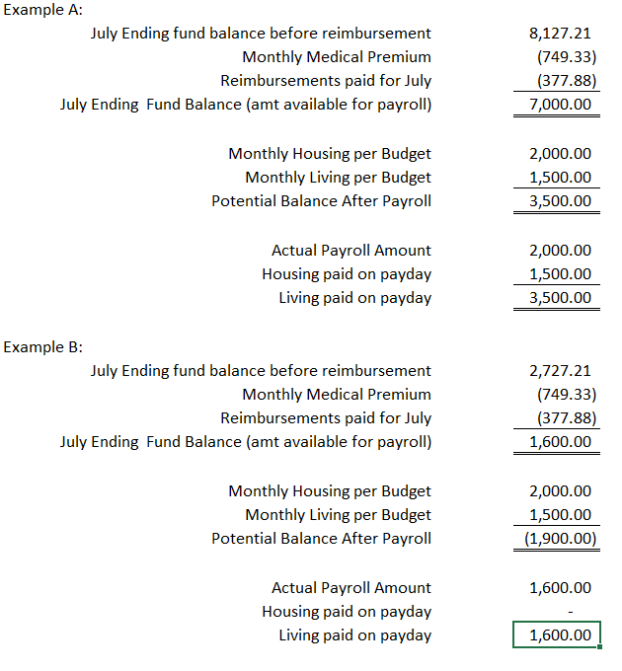

Payroll Taxes

 |  |  | Social Security
 | Federal | State | FICA
 | Income Tax | Income Tax | Employee | Employer | SECA | W-4
Minister | Living Allowance | Check with state | N/A | N/A | 15.3% of Living and Housing paid by employee | Required by ISI
Non-minister | Total Salary | Check with state | 7.65% | 7.65% | N/A | Required by IRS
 | (1) | (2) | (3) |  | (4) | (5)

- ISI withholds federal income taxes on the taxable portion of your income. For ministers, the taxable portion is only the living allowance. For non-ministers, the entire salary is taxable. Amounts contributed to the Retirement Savings Plan are excluded from taxable income.

- ISI currently can deduct state income tax on the taxable portion of your income for all states where we have employees. We are working on registering in all of the states where we have employees. As we obtain the necessary registrations for each state, we will let the employees in that state know we can start withholding state taxes. As ISI expands into new states we will apply for the appropriate permits in the state for the following: state income tax, workers comp, sales tax, sales tax exemption, etc.

- Non-ministers are required to contribute to the Federal Insured Contribution Act (FICA) for social security purposes. The employee pays 7.65% and the employer matches this amount out of your ministry account. Ministers are considered self-employed in regards to social security. Ministers are covered by the Self Employment Contributions Act (SECA). Employers cannot withhold SECA from the salary of the employee. However, additional federal income tax may be withheld to cover the minister’s self-employment tax liability (SECA). Additional federal taxes may be withheld by simply completing a new W-4 and sending it to the Finance Department. SECA applies to both Housing and Living Allowances. The full SECA rate is 15.3%, but the effective rate fluctuates slightly based on your tax bracket.

Ministerial services are subject to self-employment tax unless:
- The minister is a member of a religious order whose members have taken a vow of poverty, or
- The minister has requested, and the IRS has approved an exemption from self-employment tax (See attached Form 4361 for additional details.)

- The payroll department at ISI needs to have a completed W-4 to properly withhold Federal Income Taxes.

- ISI is exempt from unemployment insurance in most states. If this is a concern for you please discuss your concerns with People Services or the Senior Accountant.
When do I start getting paid?

When a new employee starts with ISI, they are put on Partnership Development (PD). That means they do not actually work full-time with students but are actively engaged in raising their support and donor base. Each employee works closely with one of our PD Couches until they are at 100+%. As you work at raising support, funds will begin to build in your account. It may take a couple of months for the flow to begin. If you are coming to ISI from a previous ministry, you can’t notify your donors until after you have been accepted with ISI and have received an account number; so it can take a few weeks for support to begin coming into your ISI account.

In the meantime, do begin submitting reimbursement requests monthly and you will be reimbursed according to the policy outlined earlier in this manual (pg 5). For further information regarding when you will begin receiving a pay check please consult the 100% Plus NSO Manual you received from your Partnership Development Coach at NSO.

How to Qualify for a Partial Salary

One of the bumps in the road traveled during PD is how to support yourself/family while you are raising support. This is why we encourage you (and/or your spouse) to continue some form of employment during at least the first part of your PD. One way ISI can help you is by paying you a Partial Salary (PS) during your PD if you qualify. It is not required that you receive a partial salary during your PD period. Receiving a PS is an option open to those who request it and qualify according to the criteria below.

Who qualifies for a minimum PS of $500/month? If your approved ISI budget states that you will work for ISI less than 24 hours per week or if your approved ISI budget states that you will work for ISI 24 or more hours per week and you have qualifying health coverage in place, then you may request a $500 per month partial salary once the receipted income to your ISI account averages at least $1,200 per month for three months. This means that you cannot receive a PS for at least three months after attending NSO and beginning your PD. If your approved ISI budget states that you will work 24 or more hours per week and you do not have qualifying health insurance in place, then on the first of the month following the beginning of your partial salary, we must begin your coverage on the ISI GuideStone plan. In this case, you may request a $500 per month partial salary once the receipted income to your ISI account averages at least $2,200 per month for three months. The premium for your health coverage will be deducted from your ISI account balance, not from your partial salary.

In order to start receiving a Partial Salary you must submit a request for partial salary to the Director of Field Development (DFD) (based on at least three months of donor income). The DFD may seek input from the PD coach, local supervisor, and/or the Regional Field Director (RFD). After checking the qualifications for partial salary (above), if at least a minimum partial salary of $500 per month can be approved, the DFD will request the finance department (and copy People Services, the staff member’s PD coach, and RFD) to begin the PS in the first possible pay period.

Once you have started on a PS, if your average donor income exceeds the minimums ($1,200 or $2,200/month), you may request a proportionately larger partial salary. A PS must remain in place for at least two pay periods before requesting an increase based on increased donor giving to your ISI account. Any reserve funds in your ISI account will also be considered when determining eligibility for partial salary. Exceptions to this policy will be considered on an individual basis.

Back pay/Short pay
In consideration of the unique challenges presented to those who raise funds for their personal support including payroll, ISI will track the difference (short-pay) between the amount of a field staff member’s budgeted salary that they are currently authorized to receive (allowance) and actual payroll, for the current and immediately-preceding fiscal years except when specifically requested not to do so by the employee. As funds exceeding the current payroll amount become available in the field staff member’s personal ministry account, these prior accumulated shortages will be back paid in accordance with usual and customary payroll procedures, thus reducing the short-pay accumulations in aging order. Short-pay accumulations for any given fiscal year that have not been back paid by the end of the following fiscal year will be forfeited.

Sample Calculation

Budgeted Salary:
Annual Monthly
Housing Allowance $24,000 $2,000
Living Allowance $12,000 $1,000

If the July ending fund balance available for payroll is $1,600.00, then the August 15th paycheck would consist of a Housing Allowance of $1,600.00. This would result in a short pay situation of Housing Allowance $400.00 and a Living Allowance of $1,000.00.
If the August ending fund balance for payroll is $3,300.00, then the September 15th payroll would be:
Ending fund Balance $3,300.00
Current Housing Allowance $2,000.00 Current Housing Short pay $400
Current Living Allowance $1,000.00 Current Living Short pay $1,000
Balance available for back pay
to be used to cover short pay $300.00

This balance would be paid as Housing Allowance. Therefore the September 15th paycheck would include a Housing Allowance of $2,300.00 and a Living Allowance of $1,000.00. This back payment of salary would result in a year-to-date short pay situation of $100.00 Housing Allowance and $1,000.00 Living Allowance.

If the September ending fund balance for payroll is $4,000.00, the October 15th payroll would be:
Ending Fund Balance $4,000.00
Current Housing Allowance $2,000.00 Current Housing Short pay $100 Current Living Allowance $1,000.00 Current Living Short pay $1,000 Balance available for back pay
to cover short pay $1,000.00

This would be divided $100.00 to Housing Allowance and $900.00 to Living Allowance. Therefore your paycheck will show a Housing Allowance of $2,100.00 and a Living Allowance of $1,900.00. This back payment of salary results in a year-to-date short pay situation of Living Allowance of $100.00.

403(b) Tax Sheltered Annuity (TSA) Retirement

ISI does not have an actual retirement plan which the company maintains and manages. However, as a 503(c)(3) non-profit church, we do qualify to have a 403(b) retirement plan. That means that we can make pre-tax salary reductions from your paychecks and contribute them to into a qualified plan. ISI uses GuideStone for our carrier and we have a local broker in CO which all staff who wish to take part in the Retirement Saving Plan must go through when setting up an account. You can obtain the necessary documents and contact information from People Services at the Home Office.

You should consult the IRS Publication 571 or a CPA in order to find out information regarding how much you can have withheld from your salary and what the limits are. ISI has a form of matching for your TSA. We will provide matching up to 5% of your taxable income. The match portion of your contribution will be taken out of your ministry account (yes, that means that you have to raise it). The good news is that this amount is not reported to the IRS as income. It is simply put into your investment account at GuideStone. You may make changes to the amount which is withheld form you salary at any time. You will simply need to login to the finance web page and print a copy of the Retirement Savings Agreement and fax it into the Finance Department with the desired changes.

Flexible Spending Arrangement (FSA)

Section 125 Cafeteria Plans allow you to use pre-tax dollars to pay out-of-pocket medical expenses, dependent care expenses, and non-employer sponsored insurance premiums. The amounts deducted from your salary to pay for these expenses are called elections. You elect an amount you wish to have deducted from your salary. These funds are withheld from your salary and deposited into a Flexible Spending Account (FSA). FlexSystem maintains these funds in an account until reimbursement is requested by you. You may request reimbursement anytime a qualified expense has been incurred. The service related to the expense needs only to have taken place; it need not be paid before requesting reimbursement.

When making the decision on how much to include in your election, it is important to be conservative in making elections because any unused funds left in your account at the close of the Plan Year are not refundable to you and are returned to ISI for use in the National Ministry Fund at the Home Office. Participants may change their FSA elections during the Plan year only if the experience a change of status such as a marriage or divorce, birth or adoption of a child, or a change in employment status. In addition, during each Plan Year anniversary you may change elections for the next year.

Health Savings Account (HSA)

An HSA is a personal savings account that you to use pre-tax dollars to pay out-of-pocket medical expenses, provided that you are enrolled in a High Deductible Health Plan (HDHP). The amounts deducted from your salary and deposited into your HSA are called elections; you elect an amount you wish to have deducted from your salary up to the federal annual maximum. Wells Fargo Bank N.A. is currently our account provider and maintains these funds in an interest-bearing account until reimbursement is requested. You may request reimbursement anytime a qualified expense has been incurred and it will be reimbursed if funds are available in your HSA. You will also be issued a “debit” card for use in paying expenses at the point of service (subject to fund availability).

When making the decision on how much to include in your election, it is your responsibility to ensure that you do not over-fund your HSA. The annual maximum contribution amount is listed on the enrollment forms for your convenience. Participants may change their HSA elections during the year at the beginning of each quarter. In addition to having deductions from your payroll to fund the HSA, you may make deposits directly into the account without notifying ISI. If you have questions regarding that process, please contact Wells Fargo Health Benefit Service directly.

As you consider funding an HSA, please also consider your participation in the FSA. You MAY participate in both (but you do not have to do so). IF you choose to participate in both, you will need to restrict your participation in the FSA medical reimbursement component (you may still contribute to the other components of the FSA -- transportation expenses, dependent care expenses, and non-employer sponsored premiums--without concern for the HSA). Limit your contributions to the medical reimbursement component to only what you anticipate for DENTAL and VISION expenses and then reimburse ONLY those expenses from your FSA. It is illegal to use an FSA for medical expenses (other than dental and vision) if you are contributing to an HSA.

Life, dental, and vision Insurance

As a benefits eligible employee working a minimum of 24 hours per week, you may elect to participate in one of these insurance plan with ISI. You should contact the People Services Department for the appropriate forms to fill out.

VI. Budgeting Process

Each field staff member who will be raising support will complete a ministry budget prior to employment and will revise it annually according to the Finance Department schedule. We need to have the Housing Allowances approved at the spring board meeting. We put together a new budget for each staff member and send them out the first week of March. This is the time when you get to re-evaluate your salary and expenses and make changes within the guidelines set by the Board of Directors and the Home Office. The budget is the same as the one which you filled out when you first came on staff. The Finance Team provides some guidelines in order to assist you.

Salary: This portion of the budget is used to meet all personal living expenses. First, we look at the CPI (Consumer Price Index) or COLA (Cost Of Living Allowance) which is published by the government each January. We look at the country in total, not at each state, and determine if there needs to be an increase across the board for everyone. Second, we take a look at whether or not each staff person is within the salary ranges which the Board of Directors has mandated. The next page has a diagram of how the Home Office determines salary increases and/or raises. If you are below the range for your position, you are required to increase your salary by a minimum of the CPI; however, you may increase it to any amount above the CPI. If you are above the range you are not allowed an increase. If you are under-supported as outlined below, you may not receive a CPI increase. Otherwise you are free to increase as much as you want within the ranges. Third, we take a look at each staff person to determine their level of support. If you have been paid 95% to 100% of your salary for the last twelve months you are allowed to give yourself a raise. If you are below 95%, then you may only increase your salary according to the CPI guideline mentioned previously. The reason for this is that if you are having difficulty raising your current support, it will be even more difficult to raise a higher amount.

Ministers are allowed to elect a Housing Allowance. This is an annual election and the minister will be required to justify to the IRS when they file their taxes the amount actually spent on Housing vs. the amount that was paid as Housing Allowance. Any excess payment of Housing Allowance will become taxable income when you file with the IRS.

Within salary range
Below range
Over range

100% + budget
100%+ of budget
No increase
CPI + unlimited increase allowed

Mandatory raise to range + unlimited increase
Mandatory raise to range

CPI, No increase
NO
YES
YES
YES
NO
YES
NO
YES
NO

Expense: Ministry funds, necessary to carry out the day-to-day ministry activities, including but not limited to expenses related to events, travel, fund raising, student activities, and professional development. The Finance Team provides each staff person with the actual expense they have incurred over a 12 month period. Your expenses for the next fiscal year should be within a 25% variance +/- of your actual expenses. This will give your supporters a clear picture of your ISI financial situation when they inquire. Other issues that are figured in the budgeting process are: escrow, FICA, and SSA. Each of these are clear cut as they are predetermined or set based on percentages or amounts.

FICA/SECA: For staff who are not ministers the budget form will automatically calculate the FICA match. This is 7.65% of your gross salary (includes both housing and living) and is sent into the Social Security Agency for you. Staff who are ministers do not have FICA taken out of their wages and do not have a matched amount from the ministry account. They are responsible for the full 15.3% of SECA on their own as the IRS states.

Escrow: ISI’s policy is that we will hold a certain amount from your account into an escrow account in order to assist staff in saving money to attend the annual National Conference. The amount that is reserved (set aside) varies from year to year depending on how much the conference is expected to cost. You may always increase the amount set aside to accommodate a spouse attending with you or if we have a family conference and you would like to bring your children. The escrow account is to be used only for the National Conference not Regional Conferences unless you have an approval from the Executive Office. After the annual conference is over and you have submitted all of your expenses for reimbursement, you may request any excess funds in the escrow account be transferred back into your ministry account for current needs. You may also choose to leave the money in escrow to be used for the next year.

SSA: Staff Service Allocation (SSA) is assessed on all receipted contributions. The SSA is used to cover the administrative costs. The SSA is subject to change at the discretion of executive management and the ISI Board of Trustees as appropriate. The rate assessed depends on the type of account: regular ministry and city accounts =15%; retirees and Canadian accounts are at 8.5%; memorial fund, events, special, and RFD accounts = 10%; benevolence and scholarship accounts = 0%; retiree and ISMC Staff =5%.

Secondment: secondment is handled on a case-by-case basis with the recipient of the seconded staff generally receiving 5% of the total SSA. The SSA is an administrative fee to help cover the cost associated with processing donation, tracking fund balances, and a multitude of other items provided by the Home Office. You may obtain a copy of a flier from Donor Services which explains this in more detail. The calculation for this is a little tricky because if you need to increase your budget by $10 for SSA then you will need more money taken for SSA as the receipted contributions has been increased. The way to calculate taking this into consideration is to divide the subtotal line by 1 - .16 or 84%. You are not assessed a SSA% on transfers or miscellaneous income.

Example 1:

Receipted $ 100.00
SSA (x 15%) 15.00
Total 115.00
If you simply take the receipted contributions times 15% your SSA is only $15. However, if you take the total amount to be raised times the SSA% (115 * 15%) you come up with an actual SSA amount of $17.25 being taken from your account. This leaves you with a shortfall for salary and expenses of $2.25.

Example2:

Receipted $ 100.00
SSA (÷85%) 17.65
Total 117.65
If you take the receipted contributions divided by 1-SSA% you gross up the contributions. Therefore, the total contributions raised times the SSA% ($119.05 * 15%) equals the SSA amount of $17.65. After we deduct it from your account you still have the original $100 needed for salary and expense.

Signature: All budgets must be signed (electronically or on paper) by yourself and your RFD before the budgets will be accepted by the Home Office as official. When your budget is complete, please take a look at the bottom right-hand corner. Compare your new budgeted monthly amount with what the Finance Team as listed as your average monthly income. These two numbers should be close to equal or you should present a plan of action to your RFD as to how you will raise the difference in the event your monthly budget is greater. Make sure to sign and date the form and then send it to your RFD for approval.

When the budgeting process comes around each year, your RFD and/or supervisor will be able to assist you if you have questions. Also throughout the year if you want to make changes to your budget, you should contact your RFD and/or supervisor as they know your situation better than anyone here at the Home Office. They will advise you of the best course of action to take. If there is a situation which requires clarification or addition information and assistance other than what your RFD and/or supervisor can provide then contact the Finance Department and we will be glad to assist you.
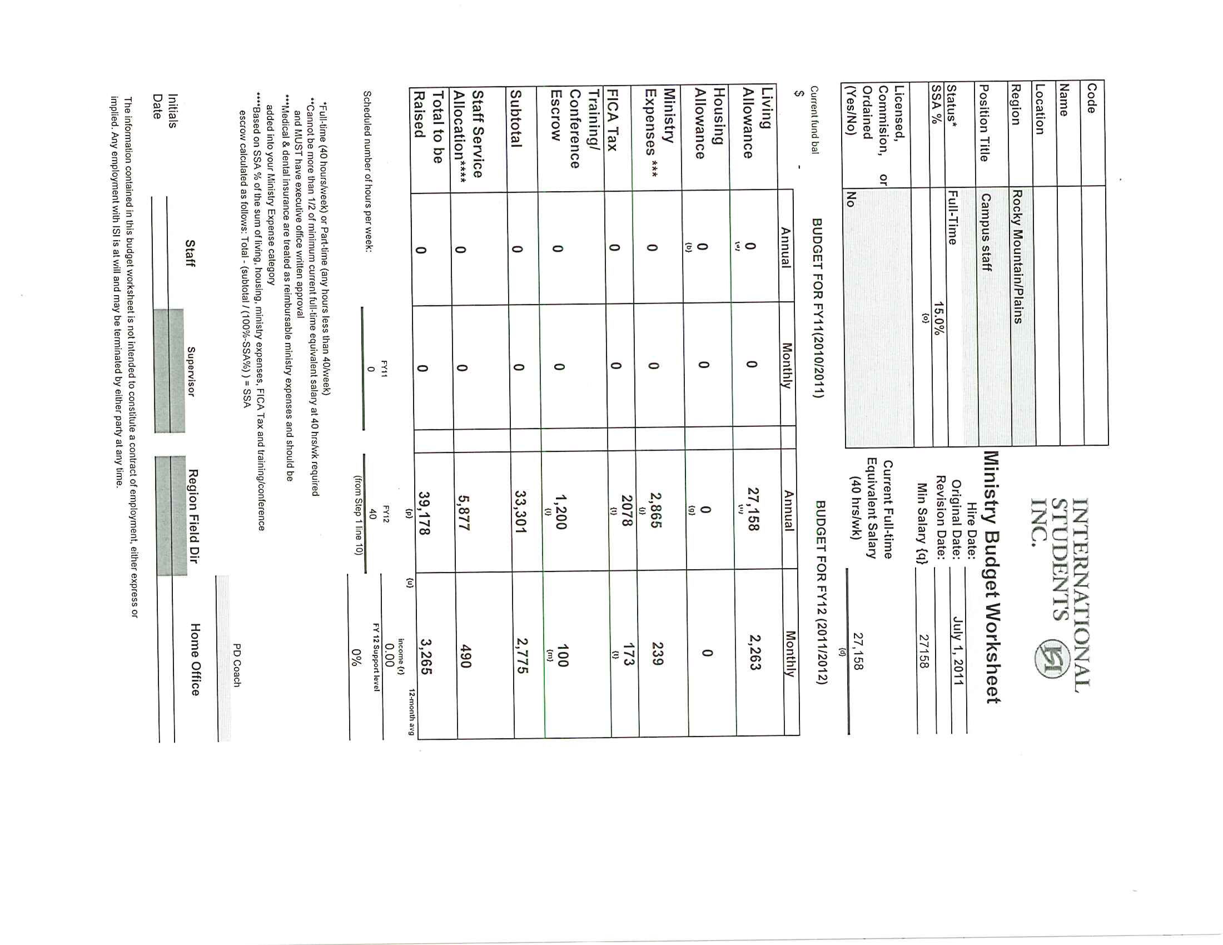
How to figure salary increase or budget change?

1) Determine what the staff person’s average income is.
a) Use the Statement of Cash Flows
b) Look at least at the past 4 months

2) Work backwards from total monthly budget; subtract the SSA, escrow, FICA and expense amounts shown on the current budget. This will give you the monthly amount available for salary
3) Calculate the annualized salary based on full-time employment to make sure the staff person is in salary range.

July 4943
Aug. 3660
Sept. 3667
Oct. 5460
Nov 3609
Dec 7696
Jan 3007
Total 32,042 ÷ 7 months = 4577.43 average monthly income

If the person you are working with is married, you must determine what % of the account is allocated to each based on current budget information.

Current budget = 2187 ÷ 4469 = 49%
Current budget = 2282 ÷ 4469 = 51%
Total budget 4469

Staff #1
2,242.94 total monthly budget (4577.43 x 49%)
381.30 SSA %
1,861.64 Subtotal
75.00 Escrow
0.00 FICA
317.00 Expense
1,469.64 Total Monthly salary

1,469.64 x 12 months = 17636 annual salary
17419 current salary
216 salary increase

Staff #2 (spouse)
2,334.49 total monthly budget (4577.43 x 51%)
396.87 SSA %
1,937.62 Subtotal
75.00 Escrow
0.00 FICA
375.00 Expense
1487.62 Total Monthly Salary

1487.62 x 12 months = 17,851 annual salary
17,327 current salary
524 salary increase

VII. Partnership Development

The 100% Plus Program: ISI’s Investment in Employees
This program was designed and is monitored by the Executive Department and the Director of Field Development of ISI. Each employee on Partnership Development is a part of 100% Plus from the day he or she is accepted with ISI, until his or her full budget is reached. This program is called 100% Plus because it is understood that in order to average 100% of their budgeted receipted income throughout the year, employees need to raise more than 100%.

The best and fastest way for one to achieve 100% of his or her budget is to work closely with someone who will encourage and keep him or her accountable to a weekly plan. Those who work with employees in this program also raise support. They fully identify with what each new employee is doing. A coach will stick with each employee, pray with him or her about appointments and opportunities to share, and rejoice with the employee as God is seen at work on his or her behalf.

Most new field staff members come already involved in ministry at some level. If new field staff members bring some support with them from a previous organization, ISI will determine how many hours per week they may work in local ministry. If employees do not have 100% of the budget ISI sets for them, they will be asked to spend the majority of their time in the ministry of support discovery. If a new employee is raising support for the first time, he or she will be spending all available time in support discovery with a minimal amount of discretionary time in local ministry. ISI will negotiate with each individual how much time may be given in each area.

Partnership Development for Veteran Staff
If a veteran employee’s year-to-date support falls below 100% for three consecutive months, the employee will be employed in an appropriate partnership development program until the year-to-date support level is at 100% of full budget for three consecutive months.

Monitoring PD success

Upon completion of the hiring process, all staff are put onto Partnership Development (PD). Each staff member is assigned a PD coach. They discuss techniques and report their progress based on a pre-determined schedule that is set up with their PD coach. As stated on section III page 25, new staff do not receive a paycheck upon initial hiring until their PD coach has suggested a Partial Salary (PS) stipend be implemented. During the first few months, income (donations raised) usually is used to cover their expenses for NSO, materials and their PD expenses.

Who qualifies for a minimum partial salary of $500/month?
- If your approved ISI budget states that you will work for ISI less than 24 hours per week or if your approved ISI budget states that you will work for ISI 24 or more hours per week and you have qualifying health coverage in place, then you may request a $500 per month partial salary once the receipted income to your ISI account averages at least $1,200 per month for three months. Please note: this means that you cannot receive a partial salary for at least three months after attending NSO and beginning your PD.
- If your approved ISI budget states that you will work 24 or more hours per week and you do not have qualifying health insurance in place, then on the first of the month following the beginning of your partial salary, we must begin your coverage on the ISI GuideStone plan. In this case, you may request a $500 per month partial salary once the receipted income to your ISI account averages at least $2,200 per month for three months. Important note: The premium for your health coverage will be deducted from your ISI account balance, not from your partial salary.

For additional information regarding Partnership Development reference the PD Manual or call either your PD Coach or the Director of Field Development (DFD) [1-719-576-2700]

VII. Donor Receipting

Our objective is to process and help maintain the integrity of donor relations through accuracy of all charitable contributions received for the ministry of ISI. We are here to serve you and your donors. All contributions and miscellaneous income are processed through this office. We code the gifts, enter them into our donor database, send receipts, and issue Donor Activity Reports to field staff. We are responsible for daily bank deposits and daily reports to the Executive Office and the Finance Manager. We maintain the records for all donors and constituents to be used for mailings and correspondence.

ISI accepts contributions according to the IRS guidelines for Deputized Fund-Raising Rules. There are a series of tests which are performed to which we must adhere in order to continue to accept contributions as tax-free. The main two tests considered are: Intended Benefit and Control. Control is the difficult piece to determine in order to show that the funds are not simply “passed through” to an individual but are managed and controlled by the 503(c)3 non-profit organization. A few of the control tests are:

- A budget process
- Continual review of programs and policies
- Staff salary set by organization
- Wages reported on IRS Form W-2
- Expense reimbursed per IRS pub
- Formal employee application process
- Training, development and supervision of workers
- Staff assignments determined by ISI; not staff preference
- Regular communication to donors by ISI
- Annual audit performed by unrelated third party

In addition, ISI staff should be aware, understand, and communicate with donors that the funds contributed are NOT the possession of the staff member but of the organization as a whole. Contributions are made with the understanding that ISI has complete control and administration over the use of the donated funds.

ASSIGNMENT OF FUND CODES

The Ministry Advancement Manager assigns a fund code to all staff for payroll or reimbursement purpose. However, some staff (administrative assistants or interns) may only submit reimbursements from a city account that already exists, so a fund code will not be assigned. When a staff member is hired, the People Services Coordinator will request a fund code from the Ministry Advancement Manager for the staff member required to raise support. A staff member may request a fund code to be assigned by the Ministry Advancement Manager for specific projects (a city, event, etc.). Each request will be considered on a case by case basis contingent upon purpose and necessity of the fund. In general, we allow two accounts for individual ministries and no more than three accounts for city/area/regional ministries.

Ministry Fund Codes: These are assigned to all staff, ministry representatives, and retirees who raise money for salary and/or ministry expenses. Before a fund code may be issued, a budget must be developed and approved by an RFD and the Home Office.

City, Event, or Scholarship Fund Codes: These are assigned when City Directors and RFDs communicate the special need for an additional fund code and discuss the use of the fund with Ministry Advancement and/or Finance to ensure the correct usage of the funds. City accounts are for student, volunteer, donor, etc. activities for/in the general city area. These accounts are overseen by a City/Area Director or RFD. Event accounts are for FUND RAISING events such as a banquet or golf tournament (there is a separate manual available regarding type of events). Scholarship accounts are for the provision of funds for students, staff, etc. to attend conferences and/or retreats, whether sponsored by ISI or not. A scholarship account is not designed to reduce all attendee’s fees but only those who have a financial hardship. A scholarship account should have a committee assigned to ensure that distribution is equitable. Memorial accounts are rare and usually set up in recognition of ISI staff. The use of the fund is designated at the time it is set up. These accounts are set with a 5% SSA and are only set up with Executive Department approval.

Special Fund Codes: Each staff member may request a special fund code be set up in order to raise money for special projects (i.e. a computer, overseas trip). The project must be approved by their RFD. A special appeal may be communicated to donors outlining the need with the corresponding special fund code. Wording similar to the following should be used and submitted to the Home Office for approval, in order to ensure that the intent of the donation is clear and the money is used for the intent of the donor.

…“Any excess funds which are raised for this special need will be held as deputized funds to ISI available to cover other special need items in the staff member’s budget.”

Other Ministry Accounts: Benevolence is a single account for collection of funds given specifically to mitigate hardship situations of ISI constituents. Disbursement of funds is overseen by ISI’s Benevolence Committee. Regional Accounts are accounts solely for regional purposes; used by Regional Field Directors only. Retiree accounts are simply a personal ministry account for Field staff who are eligible for retirement pay (see Retirement Pay section in this Handbook) and who have elected to continue soliciting funds. Staff of ISMC (Canada) may request accounts for the collection of contributions made by US citizens to staff of ISMC. ISI issues a tax-deductible receipt to the donor and forwards the funds to ISMC.

TYPES OF GIFTS

CASH – Cash gifts are usually checks but may include actual cash, foreign currency or money orders. These donations are processed on a daily basis, deposited in our bank account and posted to the staff member’s fund code. A cash donation will not be processed on the day it is received if the donor does not provide sufficient information for the allocation of the donation. Checks that are sent to ISI as donations must be made payable to ISI, not the individual staff member. According to our auditors, accepting these checks could jeopardize our tax-exempt status and affect the tax-deductibility of the contribution for the donor. We will return checks that are not made payable to ISI to the donors with an explanation. To avoid a delay in processing donations, be sure to stress the need to your donors to have the checks made payable to ISI.

STOCK – Stock donations may be sent to the Home Office or directly to our investment broker. If a donor wishes to give stock, have them or their broker contact the Ministry Advancement Manager to obtain the information for transferring the stock to ISI. Once the stock has been received by our broker and immediately sold, the cash value of the sale is posted to the staff member’s account as Miscellaneous Income. The donor is issued a Gift-in-Kind receipt, which acknowledges the gift, but does not assign a value.

GIFT-IN-KIND – A gift-in-kind is any non-cash gift given to the ministry. Examples include items to be given to international students in need (household goods or computers). It usually is some type of fixed asset. The donor or staff member submits a letter or email to the Ministry Advancement Manager with the following:
Donor Name
Donor Address
Date of Gift
List of Items Donated
NOTE: we recognize the donation not the value of the item. Once the donation of the item has been made to ISI, the Ministry Advancement Manager will issue a Gift-In-Kind letter, which acknowledges the receipt of a specific asset(s) as a charitable gift(s) and the date received. The donor is then responsible for determining the value of the asset with the assistance of their tax advisor.

Donations of vehicles to ISI are not allowed. The IRS has established very strict guidelines for the handling of vehicle donations. For more information regarding donating a vehicle, please reference Pub 4302: A Charity’s Guide to Vehicle Donations (pages 5 and 7). This document can be printed off of the IRS website (http://www.irs.gov/formspubs).

PERSONAL – Donors who wish to send a personal gift to staff for Christmas, weddings, other special occasions, etc., should simply write the check directly to the staff member and mail it to them. These are non-receipted contributions and do not have to be sent through the Home Office.

HONORARIUMS – Gifts received for speaking at a church, event, conference, etc. should be made payable to ISI and sent to the Home Office. This is a miscellaneous gift and is not subject to the SSA%. Honoraria are gifts given by the organization you spoke for to assist in offsetting your expenses incurred. If the organization makes a payment directly to you, you should indicate receipt of the gift by making a negative entry on your next reimbursement.

OTHER METHODS OF GIVING

Easy Giving Plan – This is a method that allows ISI to automatically withdraw a donation from the donor’s bank account each month. These withdrawals are made using an Automatic Clearing House (ACH) which constitutes an electronic funds transfer (EFT) between banks. Withdrawals are done on the 5th and 20th of the month. The donor is provided an annual Giving Statement reflecting the monthly gifts donated that year, and can contact us directly to make increases, decreases, or other changes to their donations. EGP cards with this information are mailed to donors on a quarterly basis to encourage them to sign up for this program. The donors also may find the information on the ISI website (http://isidonorservices.weebly.com/). See next page for sample.
Wire Transfers – A donor may also send their donation by means of a wire transfer, usually done by an overseas donor or a major corporation. If you have a donor who would like to give via wire transfer, please have them contact the Finance Department directly at 1-800-474-4065 or finance@isionline.org to obtain the specific account information.
Internet/Online Donations – This is a secure website from which donors may make one-time or recurring credit card donations. There are two specific designations to discuss: field staff donations and National Ministry Fund (NMF) donations.

Field Staff - Donors may visit a staff member’s personal website and go directly to the online giving page to make automatic donations on their credit cards without having to contact the Home Office or the staff member.

National Ministry Fund - Donors may sign up through the Donor Services website, http://www.isionline.org/Donate/NationalDonationForm.aspx to make a recurring monthly donation or a one-time gift. This site processes donations for National Ministry initiatives which are not specifically intended for a field staff member or city fund (for example: National Ministry, Evangelism Events).

Credit Card Donations – Similar to the EGP plan, whereby the donor calls the Donor Services Department at 1-800-474-8628 to authorize ISI to charge their credit card on a monthly basis – either on the 5th or 20th of the month. Donors may also make a one-time donation in this manner.

Contributions received by Staff

We must abide by very specific IRS Code and Designated Giving Regulations to maintain our not-for-profit and 501(c)(3) status with the IRS. Please make note of the acceptable ways for staff to handle gifts and donations you receive directly from donors. We will strictly enforce these policies at the ISI Home Office.

Checks made out to the staff:
- In order to process a check into a staff ministry or project account, it MUST be made payable to International Students, Inc. or ISI, not the staff person. The IRS recognizes the tax deductible donation from the check issuer, so if you receive a check made out to you from a donor, you have these options:
  - Ask the donor to change the payee to ISI,
  - Treat it as a personal gift – cash and use as you see fit, BUT the donor will not receive a receipt,
  - Make a copy of the check you received from the donor, go to the bank and cash it, purchase a money order and fill it out with the donor’s name and address, and then mail the money order and copy of the original check to the Home Office to process and receipt.
  - Note: money orders are a reimbursable expense.

In the past, staff members have cashed checks made out to them and then written a personal check payable to ISI with a note stating who made the gift and asking for a receipt for that donor. We will no longer receipt the donor in these cases; the receipt would be issued to the staff person/check writer.

Likewise, staff should not endorse the check over to ISI. The IRS will view this as a contribution you have endorsed over to the ministry as a charitable donation coming from you and the donor will not get the tax deductible receipt.

- If we receive a check at the Home Office that is not made payable to ISI, we return it to the donor with a letter explaining that we can only process payments made out to ISI or International Students Inc.

Cash Received Personally from a Donor:
If you receive cash intended as a donation, we do not encourage sending cash in the mail. Please consider these options:
- Ask the donor to replace the money with a check or money order made out to ISI and designating your fund for the contribution,
- Purchase a Money Order from the bank and complete it with the donor name, address and designation, and mail that to the Home Office. This will ensure that your donor gets a receipt for their gift.
- If you receive cash donations at a fundraiser, and the donor would like a receipt for tax purposes, you will need to prepare a money order, made out to ISI, for each individual gift with the name and information of the donor on it.
- Note: money orders are a reimbursable expense.

Personal Gifts:
  - Personal gifts do not have to be processed through the Home Office if they are made out directly to you. Just make sure the giver realizes they will not receive a receipt. Personal gifts are NOT considered taxable income.
  - When we receive personal gifts in the Home Office, we process them as Miscellaneous Income, not as charitable donations. The entire gift amount is remitted to you via check or direct deposit, no SSA is deducted, the money does not show up on your weekly MTD reports, and the giver does not get a tax-deductible receipt.

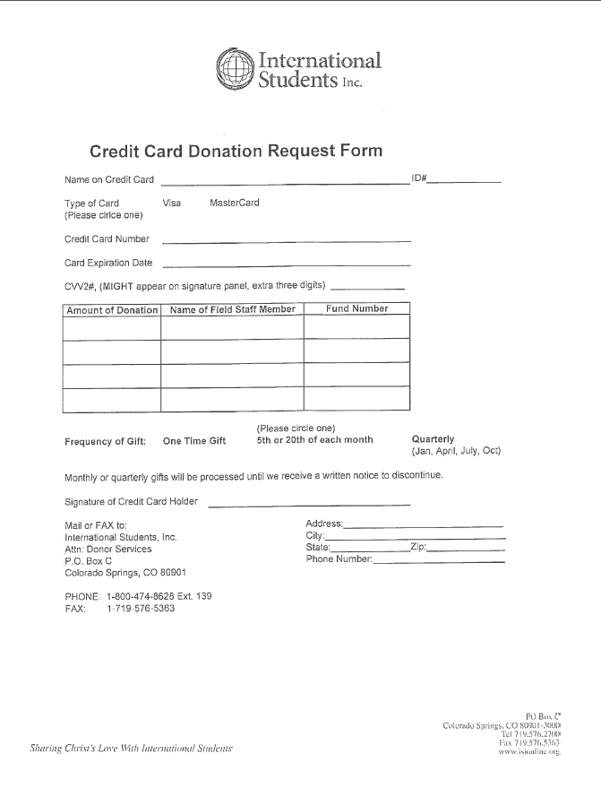
DONOR ENVELOPES (see sample donor envelope)

Donor envelopes are specially-designed envelopes that are printed with information about donating to ISI. These envelopes can be stamped with a specific staff member’s fund code and name. The donor can specify an amount they want to contribute to staff, ask for more information about ISI planned giving methods, or indicate a special project they would like to support. When staff speak at a church or at an event, these envelopes can be passed out to the congregation or conveniently left on a table for donors to pick up and mail a donation for the staff member. The envelopes are pre-addressed to the Home Office (but not pre-stamped) and help us to quickly identify a new donor to the ministry. We then set the donor up in our database and assign them a unique donor number. These envelopes may be ordered by contacting the Home Office at (719) 576-2700 or by email at orders@isionline.org.

RECEIPTS (see sample receipt)

Receipts are usually mailed out the next business day after the donation has been processed and posted to your account. Our receipts are separated into three parts:
- The Fifteen-Liner. This is an informational 15-line note which includes brief comments on conferences, ISI’s ministry outreach, as well as short testimonials from international students, and statements of appreciation from the President of ISI.
- Receipt retained by the donor for tax purposes. This will include the date and amount of the donation(s), the fund to which each contribution was posted, the year-to-date giving total, along with the donor’s name and address. This portion will not designate the actual names of the staff whom they support. Instead, they will see printed “The Ministry of ISI”. If a staff person’s name is on this portion of the receipt, the IRS will interpret the contribution as a personal gift intended for an individual and not a charitable contribution to a non-profit organization; therefore indicating the donation is not tax deductible.
- Remittance Device (also called a receipt turnaround). This portion is similar to part two except that the staff person’s name appears (instead of The Ministry of ISI) and the year-to-date giving total is not reflected. It also provides a space for the donor to write in the intended amount of the next/current donation(s) or indicate an additional amount for another staff or special project.

Sample of donor envelope

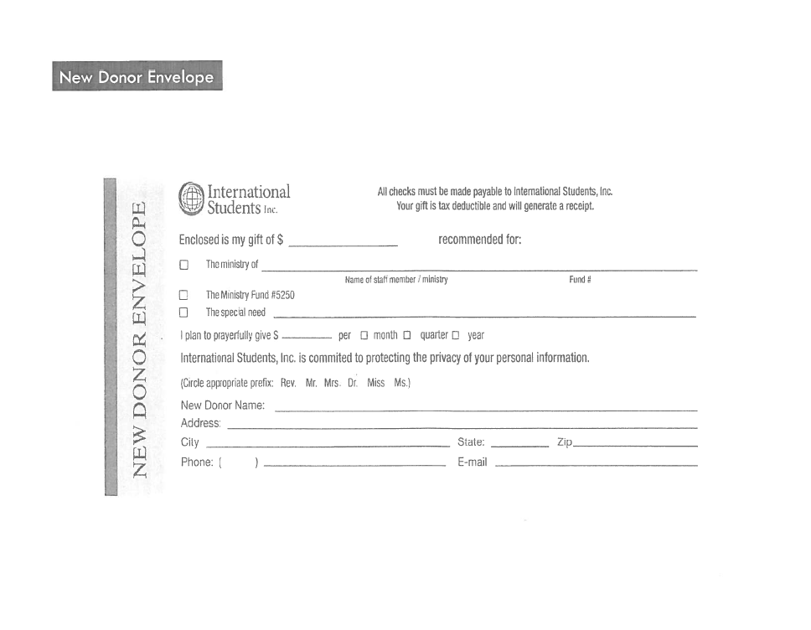
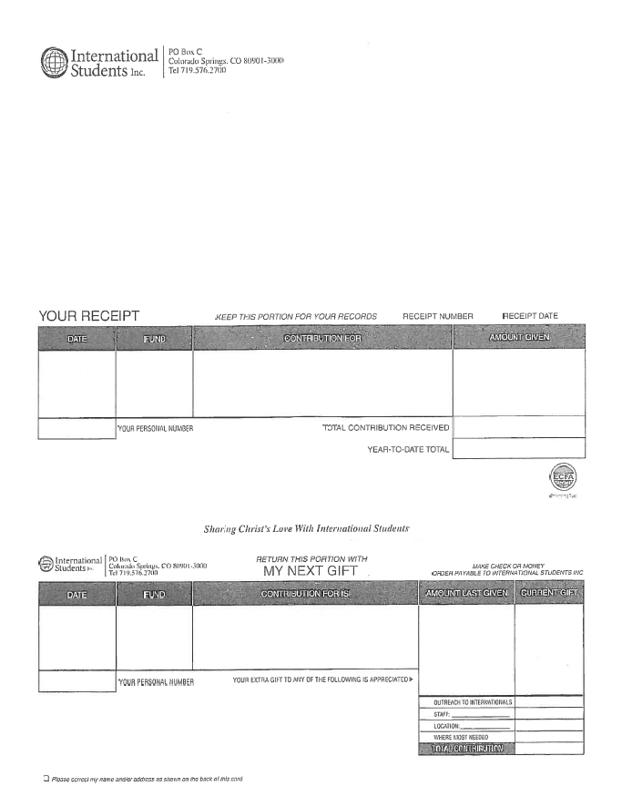

Receipt inserts are included with the receipts each month. They often include topics of interest, ministry updates, and pertinent reminders to our donors.

Listed below are examples of various inserts and the typical months when they are mailed out with the receipts. Note that EGP cards are sent out quarterly.

January Happy New Year!
February Become an ISI Prayer Intercessor
March Easy Giving Plan
April National Staff Conference
May Fiscal Year End/Special Projects
June Thank You!/Prayer Requests
July Easy Giving Plan
August National Staff Conference Resources Available
September Easy Giving Plan
October Christmas Gift to Staff
November Year-End Giving
December Easy Giving Plan

Please contact Donor Services at 1-800-474-8628 ext. 139 if you have further questions or suggestions regarding the receipt inserts.

VIII. Monthly Reports

Between the 5th and 7th business day of the month, ISI will compile a variety of reports which will be mailed to you. They include but are not limited to the Income & Spending Status Report, Fund Activity Report, and Donor Activity Report.

Income and Spending Status Reports (ISSR)

This report is a quick glance at the activity on your account. It will informl you of your end of the month balance and your income and expenses for the month. The following is a brief explanation of how to read your monthly Income and Spending Status Reports. This process is the same as reconciling your checkbook. We encourage you to spend a few minutes looking at it each month, and if there are any areas you don’t understand, drop us a note, email or call 1-800-474-4065.

Just follow these steps and match them up to the corresponding number on the sample attached for the months of November, December, and January.

- The Previous Month Balance should always be equal to the Balance Avail for Next Month’s Salary from the previous month

- Contributions for each month should match what is reported to you in your Donor Activity Report for the corresponding month. If it does not, let us know! This is the basis for the computation of the Staff Service Allocation that applies to your account.

- Reimbursed Expenses section should always match up with the amount that you have submitted for reimbursement and/or received for reimbursement.

- Non-reimbursed Expenses section are items which either you have requested that we pay on your behalf (literature, postage, etc.) and items which have been automatically charged by the Home Office (C9 fees, Escrow for National Conference, etc.).

- Salary expenses should always match up with what you actually received each month plus TSA and FICA matching if they apply to you. This section should never be greater than the Previous Month Balance.

- Monthly Change in Account is nothing more than current month’s income minus current month expenses.

- The Balance Avail for Next Month’s Salary is Previous Month Balance, plus current month income, minus current month expenses. January fund balance will be carried as the balance forward to February column, and the process starts over again.

- Balance Avail for Next Month’s Salary in December. The balance will show how much you will have available for salary in January. Remember, we consider the following expenses in this order to determine how much is available for the next month’s salary:
Previous Month Balance November (Item 1), plus December income (Item 2), minus:

Dec. Staff Service Allocation Percentage
Dec. miscellaneous inter fund transfers (either positive or negative)
Dec. Living and Housing Allowance for current month
Dec. conference escrow
Dec. reimbursements and any pending Jan. reimbursements

In the calculation above, your fund balance may be exhausted at any point. This is why some months you may only receive a partial (or no) salary (we pay as much “housing” as possible before we pay any “living” allowance).

International Students Inc
Income Spending and Status Report
5000 – Name of Staff Person (5000) 17%
November through January

 | November 1 – November 30 | December 1 – December 31 | January 1 – January 31 | Total
Income
Contributions-Receipted | 8,402.50 | 26,790.00 | 7,440.00 | 42,632.50
Contributions - Securities | 0.00 | 3,356.93 | 0.00 | 3,356.93
Total Income | 8,402.50 | 30,146.93 | 7,440.00 | 45,989.43
Ministry Expenses
Reimbursed Expenses
FT-Donor Care | 10.24 | 30.94 | 65.86 | 107.04
FT-Medical Insurance | 1,311.66 | 658.33 | 706.99 | 2,676.98
Total Reimbursed Expenses | 1,321.90 | 689.27 | 772.85 | 2,784.02
Non- Reimbursed Expenses
Escrow - National Conf | 80.00 | 80.00 | 80.00 | 240.00
Staff Service Allocation | 1,428.43 | 4,933.90 | 1,264.80 | 7,627.13
Field Staff Postage | 0.00 | 0.00 | 6.92 | 6.92
Field Staff Literature | 0.00 | 0.00 | 7.50 | 7.50
Field Staff Stationery | 40.00 | 0.00 | 0.00 | 40.00
Total Non- Reimbursed Expenses | 1,548.43 | 5,013.90 | 1,359.22 | 7,921.55
Total Ministry Expenses | 2,870.33 | 5,703.17 | 2,132.07 | 10,705.57
Salary Expense
Housing Allowance | 2,250.00 | 2,250.00 | 2,250.00 | 6,750.00
Living Allowance | 2,500.00 | 2,500.00 | 2,500.00 | 7,500.00
Total Salary Expense | 4,750.00 | 4,750.00 | 4,750.00 | 14,250.00
Monthly Change in Account | 782.17 | 19,693.76 | 557.93 | 21,033.86
Previous Month Balance
Fund Balance-Field | 51,904.51 | 52,686.68 | 72,380.44 | 51,904.51
Total Previous Month Balance | 51,904.51 | 52,686.68 | 72,380.44 | 51,904.51
Balance Avail for Next Month's Salary | 52,686.68 | 72,380.44 | 72,938.37 | 72,938.37

Field Staff Income Report

This summary information gives you a handy way to see how you are doing in terms of support-raising. The information provided on the attached report is just a consolidation of information that you already have (i.e. budget, monthly income, fund balance at the end of the fiscal year, etc.). It is our desire to give you as many tools as we have available to help you succeed in your fundraising efforts. We will be provide this report monthly. Following is a description of each column of the attached report to help you understand the information provided

Annual Budget: This is the approved budget for the current fiscal year. If you have made recent changes to your budget, they may not be reflected on this report yet. We wait until the updated budget is effective to show it on the report.

Current Month:
- Budget: The approved annual budget divided by 12
- Actual: Actual income for the month (e.g. receipted gifts, stock gifts, Canadian income)
- % of Budget: Monthly actual income divided by the monthly current budget

Prior three months % of Budget:
- Prior three months income divided by the monthly current budget

Year-To-Date:
- Budget (Adjusted for new hires*). Monthly budget times the number of months that have elapsed in the current fiscal year. (e.g.: If your annual budget is $12,000 a year and the report is for the 9th month, March, then the year-to-date budget should be $9,000). *Adjusted for new hires means that if a new staff person did not start until September, then they would only need to raise support for 7 months (September through March), instead of 9.
- Income: Actual income for the year (e.g. receipted gifts, stock gifts, Canadian income)
- Income as a % of Budget: Income divided by budget
- Carryover + YTD Income: Depending on the fund balance that you carried into the new fiscal year, you may not need to raise a full year’s budget to be at 100%. This number is the combined total of your fund balance as of June 30, 2004 plus the year-to-date income.
- % of Budget: This percentage divides the Carryover + YTD income by the YTD budget. This percentage considers the fund balance that you carried into the current fiscal year.
12-month:
- Annual budget: this is very simply your approved annual budget at the time of the report
- Income: Actual income over the last 12-month period.
% of Budget: This percentage divides the 12-month income by the annual budget. It is my opinion that this is the % which will make the most sense to you and donors. Fund Balance: Simply your fund balance as of the end of the month, after reimbursements have been paid. We use this balance as the starting point for what you will be paid on the 15th of the following month.
Days of Support: The Days of Support is calculated as follows:
- Annual budget divided by 360 to determine daily budget
- Divide the fund balance by the daily budget to determine how many days the balance will cover.
- We ask all of our staff to have at least 45 days of support in the account at all times. This provides a cushion for those times when you have a lean donation month and assures that you always receive full pay. You are considered at 100% support when you have 45 days or more of balance in your account at all times.

We hope that this information is helpful. If you have any questions with the information provided, please contact me at extension 162 to discuss your specific concerns. Thanks!

Field Income Report (broken into three lines)

Annual
Monthly
Proj # Name Budget Budget Actual % May April March
3200 Finance 42000 3500 3000 86% 3500 3100 3200
100% 89% 91%

YTD w/o carryover
YTD w/ carryover

Proj # Name Budget Actual % Budget Actual %
3200 Finance 3500 3000 86% 35000 34500 99%

12-month income

Proj # Name Budget Actual %
3200 Finance 42000 40500 96%

The Donor Activity Month-to-Date Report

This report, per Fund, is sent electronically on a weekly basis, and lists every donor who has made a contribution to date within the current month. It includes the donor’s name, their ID, the gift date, Solicitation Code (i.e. EGP, Receipt Turnaround), and the amount of the gift. The report will reflect the total number of transactions processed month-to-date, as well as the total dollar amount posted for the month.

The Donor Activity 13-Month Report

This report is sent after the close of the current month by the Donor Services Department (not Finance), and lists every donor who has made a contribution to you in the past twelve months. It will give you their name, address, email address and telephone number for contact purposes. If you notice that some of the information is outdated, or a gift has been processed incorrectly, please let us know immediately so we may make any necessary corrections!

This report also reflects which month each donor contributes and the amount they give monthly. You can monitor giving trends of your donors, and gauge your budgeting and fundraising efforts accordingly. The report will provide your year-to-date receipted income as well. The totals on this report should match the totals on the ISSR (Income Spending and Status Report) that is also discussed in this manual.

These reports are extremely helpful in fundraising as they indicate who has sent in contributions, when, and how much. They will also help you note if someone has not made their regular contribution.

Key Information to Review Each Month
- Do the contributions on Income and Spending Report match the Donor Report?
- Was the Staff Service Allocation Percentage computed correctly?
- Do expenses compare to my Expense Reimbursement Summary form plus any other known charges incurred (i.e. literature orders, etc.)?
- Is escrow amount correct? (Refer to your budget and/or any subsequent agreements you have made with the Executive Department to increase or decrease the amount.)

We hope this brief explanation helps. If you need further clarification, please call the Senior Accountant at (800) 474-4065.

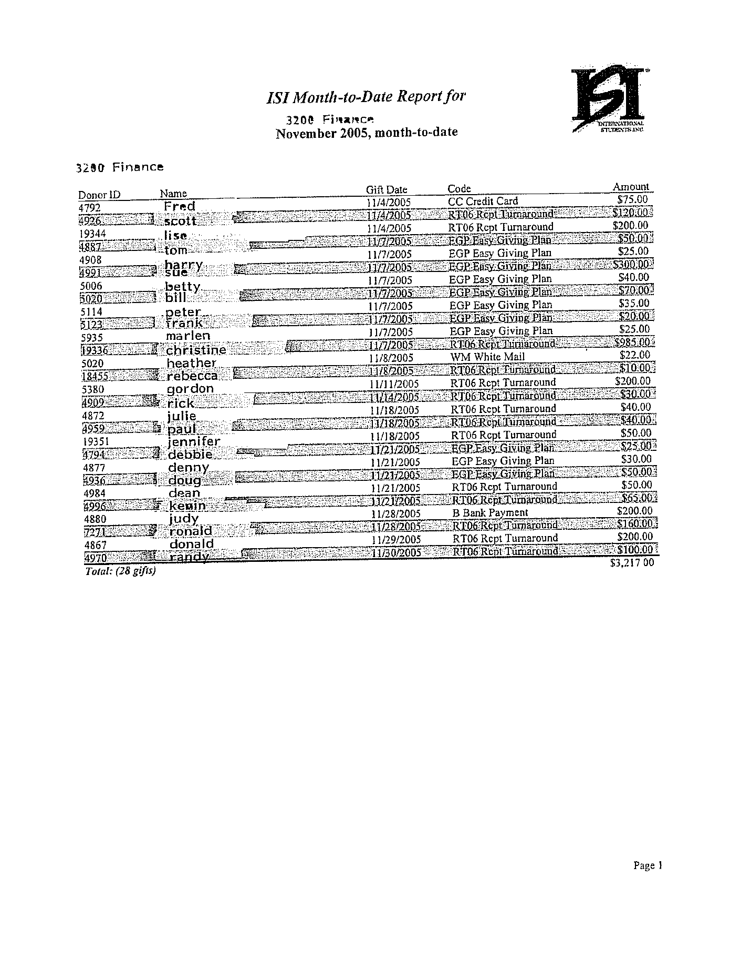

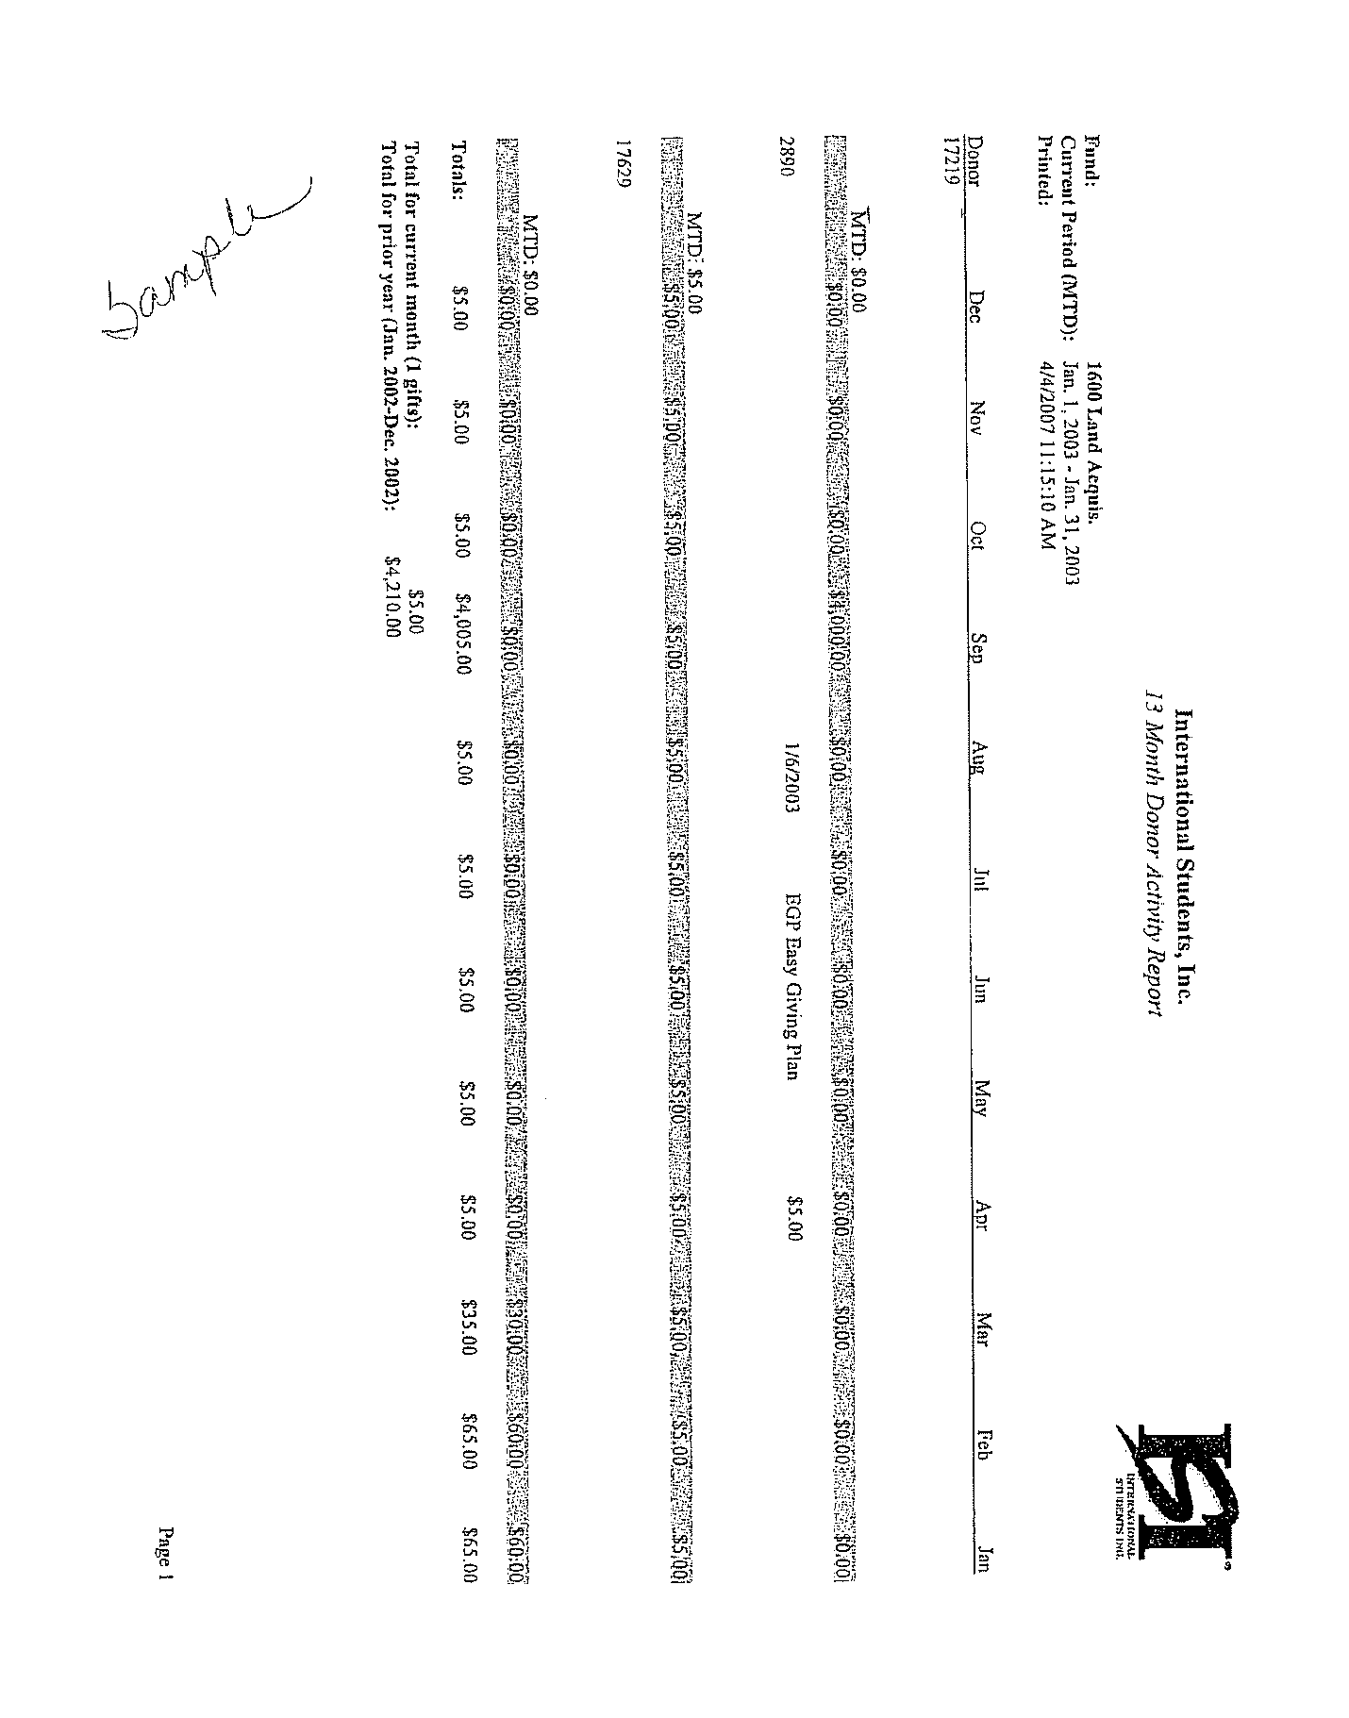
IX. Subsidiary Company Practices

A secondment will be on a case by case scenario. Citizens of the US will be seconded to the subsidiary with payroll being processed by ISI and expenses through the subsidiary provided that funds are available in the appropriate company. ISI will transfer funds between ISI and its subsidiary as needed to ensure prompt payment of expenses and payroll.

Subsidiaries will assess an SSA of 15% on all donations collected in the foreign country; with 13% going to ISI and 2% remaining in the subsidiary. Likewise, ISI will forward 2% of the 15% collected on US donations to the subsidiary.
X. Frequently Asked Questions

- What is included in the Staff Services Allocation?
The SSA goes to cover services provided, on the Field Team’s behalf, by the Home Office Team. These services include things such as: payroll, income processing, donor receipting, budgeting, processing and payment of reimbursements, insurance processing, statistical administration, production of ministry materials, assistance with mailings, donor care, etc. It also covers benefits provided in the form of liability insurance and the medical reimbursement benefit.

- If I fall short on support, can I get back pay when my account has a surplus?
Yes, we calculate back pay every month as we figure the amount of your paycheck based on the fund balance at the end of the prior month.

3. Do I qualify for the minister’s housing allowance? How much is that?
Yes, if you are an ordained or commissioned minister of the Gospel. The housing allowance (the IRS deems it a “parsonage allowance”) for any given year is based upon how much you spend for housing. The actual allowance is limited to the lesser of three amounts:
- The amount actually used to provide a home;
- The amount officially designated as a housing allowance; or
- The fair rental value of the home, including furnishings, utilities, garage, etc.

- Do I pay social security tax at the employee rate or the self-employed rate?
If you are an ordained, licensed, or commissioned minister of the Gospel, you pay self-employment taxes at the self-employed rate. You do not pay FICA (Federal Insurance Contribution Act). You are covered by social security provisions under the Self Employment Contributions Act (SECA). It is possible to “elect” out of self-employment tax (see IRS Form 4361).

5. What is included in ministry expenses on my budget?
All of the ordinary and necessary expenses that you plan to incur in order to carry out your ministry. We also include in this section of the budget any amount related to matching 403b contributions and company paid medical insurance premiums. Specifically omitted from this category are Living Allowance, Housing Allowance, Training/Conference Fees, and Staff Service Allocation.

6. Do I need a receipt for every purchase I make or is there a minimum amount?
Currently, you must have a receipt for all expenses greater than $75.00 for which you are requesting reimbursement, with one exception. The cost of food related to having international students share a meal in your home does not require receipts (only the monthly meals sheet) if they happen to drop by as you are eating.

- Is there a “time limit” for presenting receipts for ministry expense reimbursement?
Yes, expenses must be presented for reimbursement within 60 days of the time they are incurred. It is imperative that ISI maintain an “accountable plan” for reimbursements. According to the IRS, this 60-day limit must be adhered to for this purpose.

8. May I raise money for items other than my salary and expenses?
Yes, with the prior approval of the RFD, you can currently raise funds specifically for automobiles, overseas trips, and computer equipment.

9. What is the approval process for purchasing capital equipment with my ministry funds?
All equipment purchases should be included in the amount of your budget under “Ministry Expenses.” For any capital purchases greater than $2000, you must receive the prior approval of your RFD and the Finance Department and submit the original receipt within 60 days. If the purchase is of computer equipment, please run the specs by the Home Office Operations Department to ensure it will be compatible with our other equipment/systems.

- May I be reimbursed for child care?
Yes, but only if the child care is done to benefit Internationals or donors. If you are having an event and you know that there are students or donors who have children, you may pay someone to provide the childcare at the event so that those students and donors will be more likely to attend.

- Can I be reimbursed for the cost of having international students share a meal in my home?
The cost of food related to having international students share a meal in your home is requested by submitting a “Monthly Meals Sheet.” The current rate of this “per diem” is $4 per guest for breakfast, $7 per guest for lunch, and $10 per guest for supper. No receipt is required in finance. It is best to keep the receipt for yourself.

- What is meant by commuting miles?
Commuting is the distance between where you live and any location, which is considered to be a primary place of business according to the IRS. If you have a specific situation which may be considered commuting, contact the Finance Department for more information.

- May I submit cell phone bills for reimbursement?
Yes, however, you must add the minutes used for ministry to determine the percentage of the bill that is ministry related and only claim that amount. If it is over $75.00 then you must submit the bill including the minutes.

- What are the deadlines for my reimbursement reaching the Home Office?
Regular ministry reimbursement requests must reach the Home Office before 5 p.m. on the first of the month. If the first falls on a weekend, then the deadline is 5 p.m. on the last business day of the month. City or special reimbursement accounts may be submitted twice per month for each account. The deadline to have into Finance is noon on the Wednesday prior to the check being issued. These are paid out on the 2nd and 4th Thursday of the month..

- How often can I change my budget?
ISI reviews and makes changes to ministry budgets annually. At that time raises and cost of living allowances are made. However, you may make a change in your budget throughout the year if you contact your RFD and they deem that a change is necessary.

- What is an escrow and how is it determined?
An escrow is like a savings account. We transfer a set amount each month into the escrow in order to save money on your behalf to attend the ISI National Conference each summer. Every year the cost, lodging, and transportation for the conference are evaluated and new amount is set.

- How long do I have to submit receipts?
Receipts must be submitted to the Home Office with 30 days of a reimbursement being submitted to the Home Office electronically or 60 day from the date of the expense if submitted using the traditional paper method.

- What happens if I don’t submit as expense within 60 days of incurring the expense?
It will be disallowed, but you will be given the option to still receive the disallowed expense. However, it will need to be included in your taxable income for the year

- What happens if I do not have receipts turned in with0in 30 days?
If the receipts are not received within 30 days of an electronic reimbursement, all reimbursements for that staff person will be held until the receipts are received in the Home Office.

- Are there options to help me plan for Retirement?
Yes, we have a 403(b) plan in place which you can choose to have set up and contribute to pre-tax.

- Where does the matching portion of my 403(b) come from?
ISI will match up to 3% of your taxable income for retirement. The match portion of your contribution will be withdrawn from you ministry account. You will need to include the match amount when calculating how much money to raise on your budget.

- How much can I set aside from my salary for retirement?
In order to answer this question you should consult a CPA or the IRS Publication 571. What I can tell you is that any amount you want to have set aside must be taxable income. Therefore, if you only have a Housing Allowance then you cannot have a pre-tax salary deduction.

- How is my money invested?
ISI makes contribution on your behalf to Guidestone Financial. It is between you and our broker how that money is invested. You may be as risky or conservative as you want.

Index

Budget Process, 31
Salary , 31
FICA, 32
Escrow, 32
Staff Service Allocation (SSA), 32
Sample Calculations, 36
Director Information, 20
Donor Receipting, 39
Assignment of Funds, 39
Donor Envelopes, 47
Methods of Giving, 42
Types of Gifts, 41
Receipts, 48
Events and Special Project, 19
Expense Reimbursement Procedures, 10
Auto Expense, 12
Capital Equipment, 12
Donor Care, 11
Meals, 12
Ministry Operations, 11
Office Expense, 11
Overview, 10
Out-of-Town Travel, 11
Professional Growth, 13
Telephone, 11
Transportation, 12
Frequently Asked Questions, 62
May I be reimbursed for the cost of child care? 63
What are the deadlines for my reimbursement reaching the Home Office? 64
How often can I change my budget? 64
What is an escrow and how is it determined? 47
How long do I have to submit receipts to the Home Office? 64
What happens if I don’t submit an expense with 60 days of incurring the expense? 64
What happened if i do not have receipts turned in within 30 days? 64
May I raise money for items other than my salary and expenses? 63
Do I need a receipt for every purchase I make or is there a minimum amount? 64
Do I pay social security tax at the employee
rate or the self-employed rate? 62
Do I qualify for the minister’s housing allowance? 62
If I fall short on support, can I get backpay when my account has a surplus? 63
Is there a “time-limit” for presenting receipts for ministry expense reimbursement? 64
What is included in ministry expenses on my budget? 64
What is included in the staff services
allocation? 64
What is the process for purchasing capital equipment with my ministry funds? 63
Can I reimburse the cost of having an international student shar a meal in my home? 63
What is meant by commuting rules? 63
Are there options to help me plan for retirement? 65
Where does the match portion of my 403(b) come from? 65
How much of my salary can i set aside for retirement? 65
How is my money invested? 65
May I submit cell phone bills for reimbursement? 63

Monthly Reports, 51
How to read the income and spending status reports, 51
Field Staff Income Report, 54
Donor Activity Report, 58
Fund Activity Report, 58
Key information to check each month, 58
Payroll Overview, 24
How is payroll calculated?, 24
How often will I be paid?, 27
How will I be paid?, 27
Payroll Taxes, 26
Sample Calculation, 25
Partnership Development, 37
Reimbursement Procedures, 10
Addendum for City Directors and
Overview, 20
Team Leaders, 20

