Director
Supervisor
Finance Manual

Contents
Website and Student Activities 3
Reimbursements 4
Bill Payment 7
Cash Advances 10
Transfer Requests 10
Payroll/Salary 11
Budgets 13
Reports 15
Ministry fund account codes 16
Fund raising events 16
Contracts 16

Website and Student Activities

I. The Finance Department Website (http://financeisi.weebly.com/) has a lot of information which is helpful and easy to use. You may find the answers to a lot of your question at the time you have the question vs waiting for us to be in the office and return your call. Please visit us frequently. Here is the breakdown of what can be found on our website.

- Downloads
  - Reimbursement forms
  - State forms
    - W4 forms
    - Sales Tax Exempt certificates
  - Other ISI forms
    - Direct Deposit
    - Benevolence Application
    - Overseas Trip Application
    - Requisition Form
    - Transfer Form
    - Salary Reduction Agreement
  - Other information
    - Field Finance Manual
    - Rules of Commuting
    - 501(c)3 Letter
    - Forms for International Students International
    - Forms for International Students International Ltd
  - Benefits
- Who to Contact in Finance
  - Senior Accountant
  - Accounts Payable
  - Payroll
  - Controller
  - Super Heroes
  - Donor Services
- ESL
  - Only available between May and July
- IRS Publications
- Training Videos
- FAQ

II. Student Activities:
As a director you may want to look into the possibility of using a website to promote and register students for activities which you are planning in your area. If you are collecting funds for an activity, you are not permitted to set up a checking account under the name of ISI. All funds collected and disbursed for an activity must be reported to the Home Office and any excess funds must be forwarded to the Home Office for deposit into your account. These funds are not donations and will not be subject to the SSA.

Reimbursements

- Guidelines
- Minimum Amount - $50.00
  - All reimbursement requests will be subject to a $50.00 minimum per request. If you have an expense for less than the minimum amount, please wait until you reach the minimum before submitting a request.
    - Exception: Remember that ISI provides up to 60-days to submit an expense for reimbursement. If expense is nearing the 60-day limit and you have not yet reached the minimum amount, please submit your request so it can be processed as an exception.
- Personal Account Reimbursements
  - Due Date: First of the Month, 5 pm (MTN) [Exception: Due the last workday of the month when the first falls on a weekend.]
  - Limits:
    - Only one submission per month. Please combine all expenses in the month and submit one (1) reimbursement by the due date.
    - $50 minimum
  - Processing Timeline:
    - Within 10 business days after the due date (subject to approvals). In most cases, you will receive your funds in less than 10 business days, but some months may take up to 10 business days.
- City/Special/Regional Account Reimbursements
  - Due Date: 12 Noon (MTN) on Wednesdays of the 2nd and 4th weeks of the month.
  - Limits:
    - Limited to two (2) reimbursements per month on the 2nd and 4th weeks of the month.
    - Please combine all expenses in a two-week period and submit a maximum of two (2) reimbursement requests per month only on the specified weeks.
    - $50.00 minimum
  - Processing Timeline:
    - Within 2-3 business days. In most cases, you will receive your expense reimbursement funds (subject to approvals) on the Friday following the due date.
- Updates to the reimbursement form
  - Jan and Feb in keeping up with the IRS changes in mileage rates
  - Periodically throughout the year in the event that there is a special situation which mandates and change
- Non-Sufficient Funds
  - When there are non-sufficient funds to cover a reimbursement request on a personal ministry account, ISI will hold the request for payment for up to six (6) months.
  - Note: Exception—reimbursement requests from new staff in initial partnership development will be held for up to one (1) year.
As per standard procedure, when you believe there is good reason for an exception, please submit your request with a clear explanation to reimbursements@isionline.org for consideration.

- Approvals
Figuring out when to fill out a reimbursement, submitting it to the Home Office, and whether or not it requires additional approvals is somewhat of a difficulty especially for new staff. Here is a flow chart which may be of assistance.
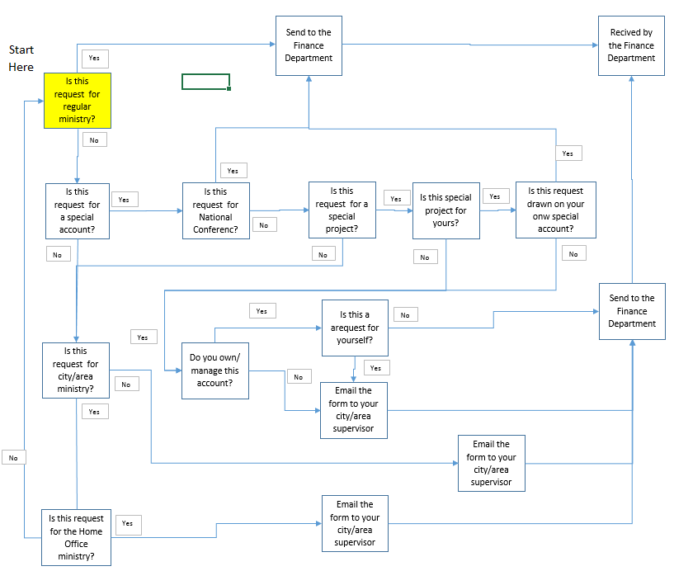

City, area, and regional account reimbursements are processed on the second and fourth Thursday of the month, provided there are funds available in the account. As a director, you are required to approve all reimbursements for staff whom you supervise and who submit a request against one of the accounts that you manage. You do not approve staff member’s personal ministry reimbursements. When you are submitting a reimbursement on an account which you manage, you should forward the reimbursement to your immediate supervisor for approval.

- Reviewing and Approving
The processes in outlined below:
- The staff member emails the request to you
- Review the request for accuracy
- Approve, reject, or adjust and forward to Finance. Include the original staff member in the forward so they know it has been approved.
- If you reject or adjust the request, you must notify both the staff member and Finance about what was adjusted/rejected and why.
- The staff member may object/appeal the decision by contacting Finance and copying the supervisor. All parties involved should be kept in the loop.

There may be questions as to what you should be reviewing when approving a reimbursement. We do not expect that you will review to the extent that Finance does as that would take a lot of time and additional training. Here is a list of some items which are quick and easy and if corrected at the director level allows us to focus on the bigger items:
- Did they fill out the summary page?
  - Name (without special characters)
  - Account
  - Description
  - Submit date
- Does the account number they are using match where the funds are to come from?
  - For example is the staff member in CO but they have transposed the account number and it is for TX
  - Directly above the account code is the title which auto-populates based on the account number entered. We don’t expect you to have all of them memorized
- Did they fill in all blanks for every expense?
  - Date
  - Who
  - Why
  - Where
  - Amount
- Is the Submit date the current date?
  - A lot of staff use an old form and forget to update the submit date which may disallow an expense due to the 60 day rule even after we have approved it but before it is keyed in the system
- Are the proper number of receipts attached with the reimbursement?
  - The top right hand corner of the summary page shows the expected number of receipts.
  - If receipts are required, there is a large green note which pops up
- Is this a reimbursement which you really should approve? These are situations where you do not need to approve the request and should send it back to the staff member. If you approve and forward to Finance, we may assume it is one thing and postpone processing when it should be done earlier.
  - Is the reimbursement on a personal or escrow account?
  - Is the reimbursement on their city account and for one of their employees?
- Is the request over $50?
  - If not, is the expense almost 60 days old.
  - If it is too old then the form should be returned until more expenses are incurred.
- Does the summary page calculate correctly?
  - If staff have made an error in typing or deleted something incorrectly, the summary page will have #ref, #Value#, or #N/A.
  - Return it for them to fix and resubmit

- Errors Frequently Observed

- Co-mingling expenses: when submitting expenses staff will include expenses from multiple accounts or escrow and regular expenses on one form. They will put a note in the form or email asking us to split this out for them. While it can be done by us it increases the possibility of errors and length of time to process the reimbursements.
- Moving expenses: while it is possible in some circumstances to be reimbursed for moving expenses. The IRS is very specific as to what and when it can be done. If staff are moving and wanting to submit expenses they should reference the Moving Guideline document on our website (http://financeisi.weebly.com/irs-publications.html).
- Trip approvals: there are two type of trips which need an approval. The first is travel within the US outside of your normal work area. These trips require that the supervisor/RFD be informed of the trip to ensure that the absence of the staff member does not have a negative impact on the ministry. The second type is overseas travel which must be approved through the Executive Office by filling out the application form located on our website (http://financeisi.weebly.com/other-isi-forms.html).
- Multiple reimbursements in one email: it becomes very timely to process as well as hard to locate specific reimbursements when they are combined in one email. In addition, if there are receipts attached we have to sort through them all to figure out which receipts belong to which reimbursement. By simply sending separate emails which each have one reimbursement and corresponding receipts it helps us to keep them separate and process in a timely manner.
- Meals while out: All of our staff travel throughout their day while doing ministry. On occasion some staff will stop to eat while out on ministry. Unless the specific meal has a direct relation to ministry (for example: a volunteer, donor, student, or co-worker (not spouse) is present and business is conducted) the expense may not be allowed for reimbursement.
- $25 gift rule: Gifts are limited to $25 per person per gift. You may be creative in this aspect such as a $50 gift to a couple for their wedding. However, when being creative we still need to be able to show how many (list names) the gift covers. Sadly, gift cards to staff members are not gifts but are instead monetary compensation by the company and therefore have to be reported to the IRS on the W2 form at the end of the year.

Bill Payment

You may submit large bills directly to the Home Office for direct payment. Bills over $50.00, that will cause a hardship in relation to having money on hand and available for regular ministry work, may be paid directly to the vendor from the Home Office. This is the process required for direct payment of a bill from the Home Office.
- Bills for all locally-provided services over $50.00 (examples: office phones, cell phones, utilities, and special event-related costs) should be sent directly to the City Director/administrative assistant, NOT directly to the Home Office.
- City Directors should:
- Review the bill for reasonableness and write “Okay to Pay” on the bill, sign and date it.
- Write account coding on the bill. This should include the city fund number from which to pay the bill and the appropriate expense category. (See #4 Account Coding below).
- Ensure there are sufficient funds in the account to cover the expense.
- Get appropriate approvals on the bill (City Directors can approve bills up to $500 and Regional Directors can approve bills up to $1,000. Amounts greater than $1,000, or capital expenses over $500, requires RFD and Finance Department approval prior to the expense being incurred). Additionally, any contract, including leases and any real property purchase must be pre-approved by the ISI Home Office regardless of the amount. Any reimbursement from a staff member claimed against the city account must have City Director approval.
- Forward the bill to the Finance Team in the Home Office.
- The Finance Team will process the bill for payment directly to the vendor in the very next check run. However, payment will be delayed if:
- Expense category and city fund number are not indicated on the bill.
- Required approvals are missing.
- There are insufficient funds in the city fund account. In this case, the bill will be held until there are sufficient funds or Finance is informed of a different project to charge.
- Account coding for bills
This is similar to the reimbursements in that we use the same expense categories. Below is an example of the expense categories including the expense codes: Transportation (50101):
Donor care (50103):
Office expense (50105
Out-of-town Travel (50107):
Professional Growth (50109):
Ministry Operations (50111):
Capital Equipment (50113):
An example of what should appear on the bill written and approved by the city directors is:
500–(one of the codes above)–city account number–initials
Example: 500–50103–5814 scj or Sheldon C. Jantz

In addition, if you would like the Home Office to make payments for conferences, scholarships, honorariums, etc. we need to have written (email) communication from you outlining the name of the person or company, address, ministry purpose, dollar amount, and date needed. If there are questions, address them to finance@isionline.org, reimbursements@isionline.org , or call the Home Office and ask for the Finance Department prior to sending the bill in for payment. This will prevent the bill from being held up while we search for the information or try to get the question answered.

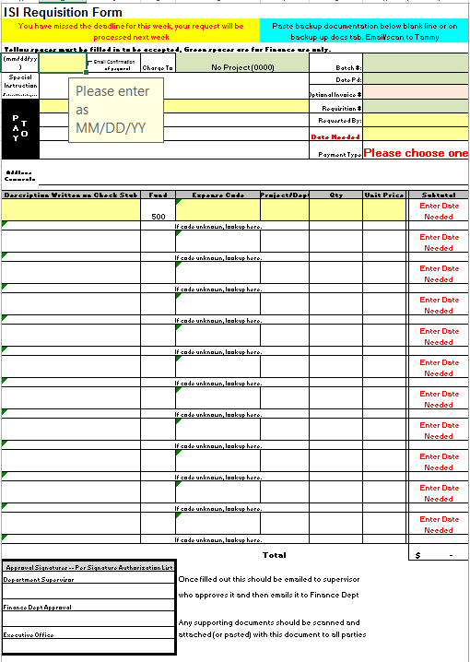

Cash Advances

Advances can also be obtained in order to have funds available to pay for large expenses. There are several things to be aware of regarding advances.
- You must request the advance in writing to include the reason and fund site to have the advance drawn from.
- Cash advances must be cleared within 30 days of taking the advance (or returning from an overseas trip).
- If the advance has not been cleared with in this time frame, reimbursements may be held or used to clear the advance.
- You may only have one advance outstanding at any given time: you cannot get a second advance if the first advance has not been cleared.

You may also request a Standard Operating Procedure from Finance regarding advances for additional information.

Transfer Requests

Transfer requests can be made from one ministry account to another provided the transfer honors the original intent of the donation and the account it was given to. Staff simply fill out the form indicating where the funds come from, how much to transfer, where to transfer it to, and why. One piece of the information is the GL code which tells Finance if this is an expense or income; most staff do not know this information so there is drop down menu to pick from. Staff may request transfers from ANY account they own to any other account provided there are funds and valid intent.

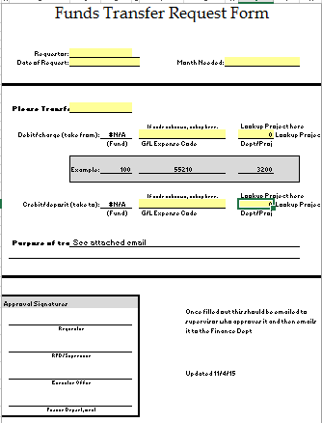

Payroll/Salary

- General Information
Field Staff are paid on the 15th (this date will be adjusted to an earlier date if it falls on a weekend/holiday) for hours worked for the entire month, but the fund balance used to determine their pay is the fund balance from the end of the previous month. Remind your staff on Partnership Development (PD) without Payroll that their payroll is driven by donation consistency & fund balance. Remind your staff on PD with a Partial Salary (PS) via payroll that their Payroll is driven by approved PD & fund balance. Remind your veteran staff released from PD that their Payroll is driven by budget & fund balance. Remind your staff that the Finance Team tracks shortages in their Payroll amount for two years from occurrence and will pay those shortages out in “back pay” in addition to their regular Payroll when their fund balance is sufficient to allow for those payments.

- Paylocity
Since International Students Inc uses Paylocity for our Payroll Processing, knowledge of and access to their website is critical for all staff. Veteran staff should be familiar with this website. However, there may be some of your veterans that have never setup their accounts or have had difficulties with access and need some assistance. Staff who are on Partnership Development will likely need a reminder about Paylocity when they are approaching release to a Partial Salary or release from PD. See Paylocity link below for logging in, resetting your password and registering a new user.

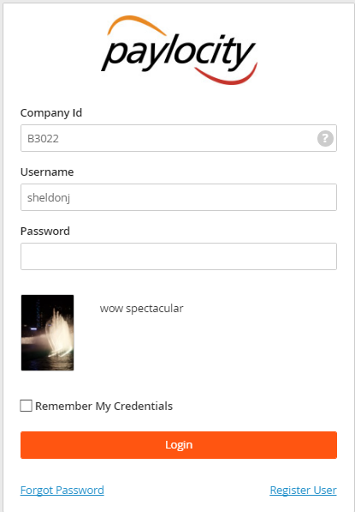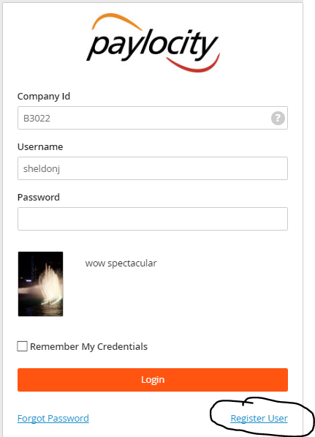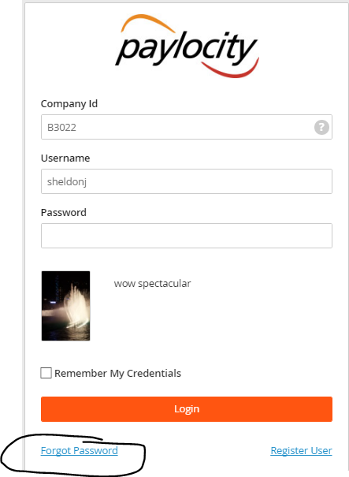

The Paylocity website (http://www.isionline.org/) is a one-stop, 24-hour shop for accessing:

- ISI News
- Company Information
- Applications
- Employee Profile
- Paystubs,
- W2’s,
- Benefits Information & Forms, etc.

This is what the site will look like and where the information listed above can be found.
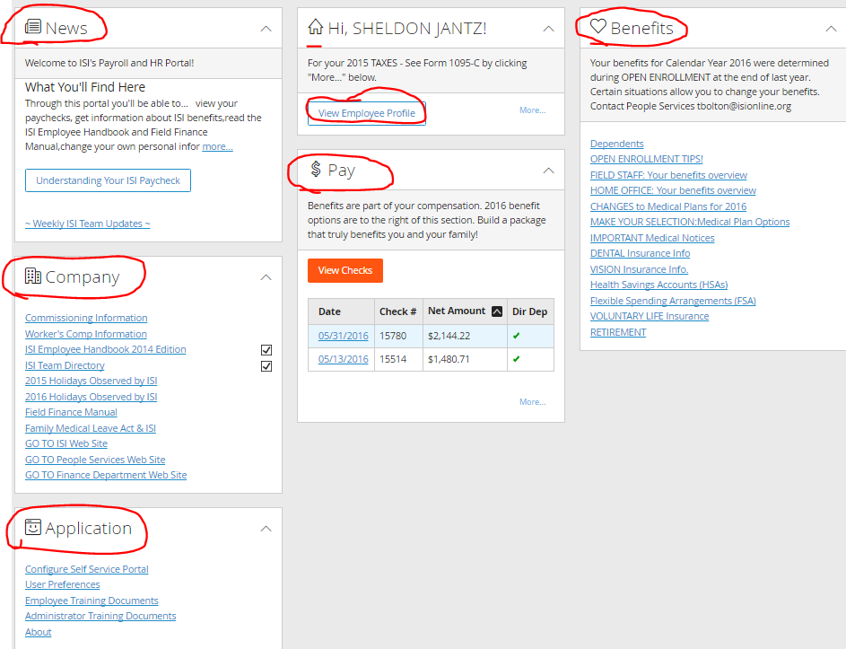

- Partial Salary (PS) Subsidy
Partial Salary (PS) via payroll is possible for new staff while they are on Partnership Development (PD). This PS is authorized and initiated by the Director of Field Development (DFD) in cooperation with the staff member, staff’s PD Coach, supervisor, and/or RFD. Regular communication between the staff on Partnership Development and their PD team is critical for timely release to Partial Salary or release from Partnership Development and full pay. As a supervisor, you should check in with new staff and/or the DFD to ensure that they are making progress. Remind the new staff to send in their reports and to have conversation with the DFD about when and how much PS new staff can be released to receive.

- City/Regional Fund Salary Subsidy
A Salary Subsidy is a means by which a Director or Supervisor may encourage staff, who they supervise as they are trying to raise their support during PD. Subsidies may be requested from a city or regional account, which the Director/Supervisor raises funds for. A Director/Supervisor may only authorize a salary subsidy for staff under their supervision, but NOT for themselves directly. All subsidies should be reviewed on an annual basis to determine if they are still needed. Staff who are at 100% support should not be considered for a Salary Subsidy. See Payroll General above for additional information.
The process:
- Requests must be submitted in a written (email) format.
- Include the amount, the account number, and the length of time of the subsidy.
  - Subsidies without an end date will not be considered.
- Any subsidy account balance, which is not sufficient to pay the subsidy in full will require an appropriate reduction in the subsidy.
- The Finance Team will not track any shortage of subsidies, nor will we make up for a shortage of a previous month.

Budgets

Every a year, ISI requires all staff (including Ministry Reps) to fill out and submit an annual budget. Budgets are used to set each employee’s salary as well as keep the Home Office and directors up-to-date with what each staff member’s plans are for the coming year. RFD’s and other directors have been asked to work with the staff they supervise in filling out these budgets. The Finance team is available to assist the directors with training and/or questions for special circumstances.

Budget Tab
On this tab there is really nothing for fill out, however, there may be several places which require your initials or feedback. If these cells are purple you should go to the corresponding tab and verify that there is an explanation AND that it makes sense to you. When you email the budget to Finance, simply indicate that you agree with the explanation. Finance will forward to the Exec Office as needed for additional approvals. If the cell is blue, then you should go to the corresponding tab and read the explanation. If you agree with the explanation initial the box on the budget sheet. If you do not, then contact the employee for additional information.

- Exp Amt Reasonable – Expense Tab
- Exception to COLA – Salary Tab
- PD Coach – Budget Tab
- Recommended Escrow Approved – Escrow Tab
- Exception to Range – Salary Tab
- CEO Approval – Housing Tab

Then you will want to verify the percentage listed as the support level. If it is close to or over 100%, then we have a good budget. If it is not close to 100%, then you want to discuss it with the employee and see what their plan is to raise the support needed. Finally, once you have reviewed these things, initial and date, and forward to your RFD or Finance.
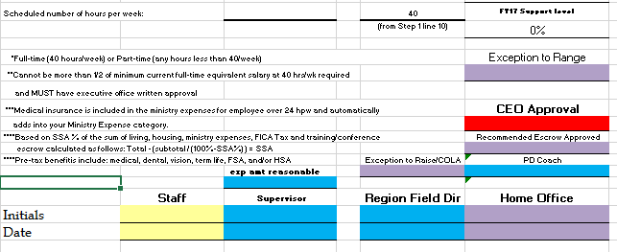

Personal Information tab
The employee should be check their name and address. All you should check is what is in blue shading to ensure that it is correct. If it is not, make the change and email Finance so we know that we need to update our records.

Salary Tab
If there are the words “Explain Below” on line 18, check the yellow box for an explanation. If “contact RFD” in highlighted on line 7, you will need to inquire as to why they are changing their hours and let them know that it will require the RFD to initial. After talking with the RFD, he will instruct you how to initial in the blue box on line 8.

There is also a calculation box for additional complex planning. For example: staff member who is not full-time says that they need to increase their salary because their rent has gone up $400. You would put 400 in box 23I and then the number of months remaining in the fiscal year in box 24I. In box 24L you list their current FTE (30000). The new FTE will calculate for you and that is what should be typed in box 18J in order to correctly adjust their budget.

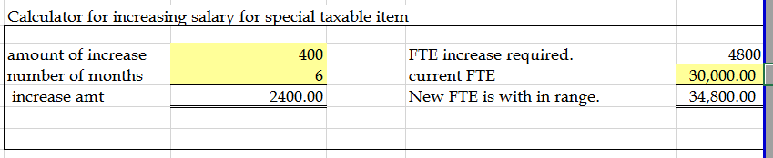

Housing Tab
There really isn’t anything for a supervisor to do on this tab other than know that ministers should probably fill in both section in order to have a housing allowance. This is required to be approved by the Board of Directors every year. The staff must fill it in so that it does not appear that the Home Office is dictating what their Housing Allowance should be.

Expense Tab
Again if line 54 reads “Explain” verify that their explanation is reasonable. The percent list on line 51 should be somewhere between 75% and 125%. You may also want to look and see if they have exaggerated one expense category more than last year as a heads up that they are planning something different. If so, have a conversation. There should be at least three yellow cells filled in with a number greater than zero in order for the new budgeted expenses to calculate and carry forward to the budget sheet.

Benefits Tab
If line 24 reads “Adjust salary”, it means that the staff have elected more pre-tax contributions than they have in living allowance. Either their salary needs to be increased, their pre-tax contributions need decrease, or their housing allowance needs to decrease. If they are not participating in either the 403b or the life insurance plan, it is recommended that you have a discussion about the option to participate to help ensure that staff are thinking and preparing for the future.

Escrow Tab
Based on the information in column L as to how many plan to attend the next year’s conference, is the amount of escrow requested on line 30 sufficient to cover the estimated cost of attending the conference. Look at line 64 column H for a quick answer. If it is sufficient and the amount requested is less than the recommended amount on line.28, initial the blue box on line 53 and ensure that the staff have initialed on line 60.

Reports
- Income Spending Status Report
There are only two areas I would recommend that you review on these reports when looking at staff whom you supervise. For those accounts which you own, please consult the Finance Manual for the specifics of what should be reviewed as recommended by Finance.
- Reimbursed expenses: two things may be notice here—reimbursements total fund balance and reimbursements are done every couple of months. In the first case, the staff member is spending their entire fund balance on ministry expenses and is therefore probably receiving little or no payroll. You should discuss with them their PD plan and or reducing ministry activity to within their financial means. In the second case, you may want to discuss time management and submitting expenses on a monthly basis to even out their cash flow.
- Salary expense: if their salary is fluctuating from month to month they are not at full support even if they have been released to full pay or are veteran staff. we would recommend talking with about a PD plan or a change in their ministry plan which can be funded by their supporters.
- The bottom line here is that stabilizing the finances to be within the support which is being raised with hopefully reduce stress and make for happier staff members.
- Field Income Report
This report was created specifically for the Director of Field Development and the Executive Office. It summarizes the budgets, support level, and fund balance for all staff and provides a means for them to measure various statistics within ISI. As a RFD you receive a report of all staff in your region. While you may not need to review all of the numbers on the report for each employee, Finance recommends that you review three pieces of it for each staff.
- 12-month income: this section shows what their average income over twelve months is compared to their annual budget. It is the support level which is used each year when prepare for the annual budget.
- Prior month income: in this section you will typically see the last three months of income and support level side by side. This is an easy way to tell if their support level is dropping steadily. If so, a discussion about PD is warranted to remind them to keep in touch with donors.
- Bal c/o trend: this section is comparing the prior month balance with the current balance. Why is this important? It will let you know if a staff member who is currently over 100% support is over spending as their balance will be decreasing over several months.

Ministry fund account codes

Fund codes may be requested as necessary. Please reference Donor Receipting section of the Field Finance Manual regarding the type and number of accounts available. Written notice of an additional account must be submitted along with: supervisor’s approval, explanation of how the fund will be used, and who is authorized to approve transactions.

Fund raising events

Fund raising events are specific events for raising funds for a city/area/region but not as some sort of activity for students. There is a 69 page unofficial event manual which is available from the Home Office and outlines the necessary procedures for putting on an event. Each event does not necessarily have to use the entire manual.

Contracts

Contracts of any nature must be approved and signed by the Executive Office. No field staff member is authorized to sign, bind, or obligate ISI in a contractual agreement. Doing so puts the entire ministry at risk not just your individual ministry funds. For additional information please reference Binding or Obligating ISI in the Employee Handbook.

